

CAPSTONE PROJECT REPORT
Report 3 – Software Requirement Specification

– Can Tho, September 2022 –

Table of Contents
Table of Contents 2
I. Project Report 5
1. Status Report 5
2. Team Involvements 5
d. Non-Screen Functions 6
e. Entity Relationship Diagram 6
3. Issues/Suggestions 7
II. Software Requirement Specification 8
1. Overall Description 8
1.1 Product Overview 8
1.2 Business Rules 9
2. User Requirements 10
2.1 Overview 10
a. Use Case Diagram 10
b. System Actors 13
c. Use Cases List 13
2.2 Authentication 14
a. UC-01 Login 14
b. UC-02 Logout 15
c. UC-03 Forgot password 15
2.3 Manage 16
a. UC-04 Manage account 16
1) UC-24 Create account by excel 17
b. UC-06 Manage Modules 18
c. UC-07 Manage Classes 18
d. UC-10 Manage Exams 19
e. UC-08 Manage Exams 19
2.4 View 20
a. UC-05 View deactivated account list 20
b.UC-19 View Exam Schedule 20
c. UC-22 Mark report 21
d. UC-23 View module list 22
e. UC-09 View module list 22
f. UC-12 View exam result, analysis 23
g. UC-15 View request add question bank 23
2.5 Exam taking 24
a. UC-20 Take exam 24
b. UC-21 Submit exam 25
c. UC-11 Export excel module's exam result 26
d. UC-13 Create exam paper 26
e. UC-14 Grade written question 27
f. UC-25 Export excel student's exam information 28
g. UC-26 Invigilate 29
2.6 Manage question bank 29
a. UC-16 Approve/reject to add questions 29
b. UC-17 Request add new question to question bank 30
c. UC-18 Assign teacher to process add question request 31
3. Functional Requirements 33
3.1 System Functional Overview 33
a. Screen Flow 33
b. Screen Details 34
c. Screen Authorization 35
d. Non-Screen Functions 36
e. Entity Relationship Diagram 37
3.2 Authentication 38
a. Login 38
b. Logout 40
c. Forgot password 41
3.3 Role Administrator 44
a. Manage account 44
b. View deactivated account 46
c. Create accounts by excel 47
3.4 Role Academic department 47
a. Manage modules 47
b. Manage classes 50
c. Manage exams 52
3.5 Role Teacher 54
a. Manage Exam 54
b. Grade written question 56
c. Approve/reject to add questions 60
d. Request add new question to question bank 62
e. Invigilate 66
3.6 Role Student 68
a. Take and submit Exam 68
b. Mark report 71
4. Non-Functional Requirements 72
4.1 External Interfaces 72
a. User Interfaces 72
b. Software Interfaces 72
c. Hardware Interfaces 72
d. Communications Interfaces 72
4.2 Quality Attributes 72
a. Usability 72
b. Reliability 73
c. Performance 73
d. Dependability 73
Security 73
e. Supportability 73
f. Design Constraints 73
g. Support Documents 73
5. Other Requirements 73
5.1 Appendix1 - Messages List 73

I. Project Report

1. Status Report
# | Work Item | Status | Notes (Work Item in Details)
1 | (Document) Report 3 | Completed

2. Team Involvements
# | Task | Member | Notes (Task Details, etc.)
 | 1. Overall Description
1 | 1.1 Product Overview | ToanTK
2 | 1.2 Business Rules | MinhHK
 | 2. User Requirements
3 | 2.1 Overview | MinhHK
4 | 2.2 Authentication (UC-1, 2, 3) | KhangTD
 | 2.3 Manage
5 | a. 1. UC-04 Manage account | ThoTA
6 | a. 2. UC-24 Create account by excel | ThoTA
7 | b. UC-07 Manage Classes | MinhHK
8 | c. UC-06 Manage Module | MinhDN
9 | d. UC-10 Manage Exams | MinhDN
10 | e. UC-08 Manage Exams | KhangTD
 | 2.4 View
11 | a. UC-05 View deactivated account list | ThoTA
12 | b.UC-19 View Exam Schedule | ToanTK
13 | c.UC-22 Mark report | ThoTA
14 | d. UC-23 View module list | MinhHK
15 | e. UC-09 View module list | MinhDN
16 | f. UC-12 View exam result, analysis | MinhHK
17 | g. UC-15 View request add question bank | KhangTD
 | 2.5 Exam taking
18 | a.UC-20 Take exam | MinhHK
19 | b. UC-21 Submit exam | KhangTD
20 | c. UC-11 Export excel module's exam result | ToanTK
21 | d. UC-13 Create exam paper | ThoTA
22 | e. UC-14 Grade written question | ToanTK
23 | f. UC-25 Export excel student's exam information | ToanTK
 | 2.6 Manage question bank
24 | a. UC-16 Approve/reject to add questions | MinhDN
25 | b. UC-17 Request add new question to question bank | ToanTK
26 | c. UC-18 Assign teacher to process add question request | KhangTD
 | 3. Functional Requirements
 | 3.1 System Functional Overview
27 | a Screen Flow | MinhDN
28 | b Screen Details | MinhDN
29 | c. Screen Authorization | MinhDN
30 | d. Non-Screen Functions | MinhDN
31 | e. Entity Relationship Diagram | MinhDN
32 | 3.2 Authentication (UC-1, 2, 3) | KhangTD
 | 3.3 Role Administrator
33 | a. Manage account | ThoTA
34 | b. View deactivated account | ThoTA
35 | c. Create account by excel | ThoTA
 | 3.4 Role Academic department
36 | a. Manage modules | MinhDN
37 | b.Manage classes | MinhHK
38 | c. Manage exams | KhangTD
 | 3.5 Role Teacher
39 | a.Manage Exam | MinhDN
40 | b.Grade written question | ToanTK
41 | c. Approve/reject to add questions | MinhDN
42 | d. Request add new question to question bank | ToanTK
 | 3.6 Role Student
43 | a. Take and submit Exam | ToanTK
44 | b. Mark report | ThoTA
 | 4. Non-Functional Requirements
45 | 4.1 External Interfaces | ThoTA
46 | 4.2 Quality Attributes | ToanTK
47 | 5. Other Requirements | ThoTA

3. Issues/Suggestions
# | Issue | Status | Notes (Solution, Suggestion, etc.)

II. Software Requirement Specification

1. Overall Description

1.1 Product Overview
ExamEdu is an online examination system supporting integrity. This system will help students take the exam online and teachers can manage these results along with creating exam questions. Besides that, ExamEdu also checks if students make fraud and announce the proctor using AI. The system will capture images of the student’s pose in the exam and return Cheating/Not Cheating results. The context diagram below illustrates the external entities and system interfaces for release 1.0. ExamEdu is expected to make online examinations more transparent.
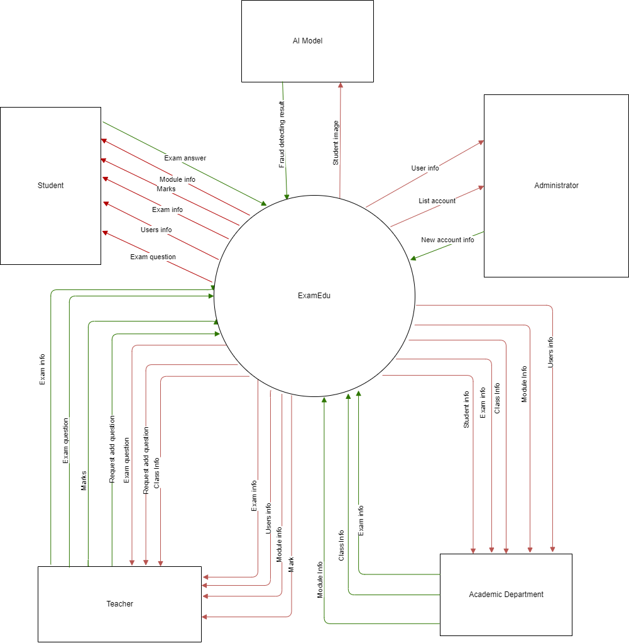
Figure 1. Data flow diagram - Context level

1.2 Business Rules
ID | Rule Definition
BR-01 | Only the Administrator can create accounts for the system.
BR-02 | Only the Head of department can view and assign the add question request.
BR-03 | Only the Academic Department can create a final exam.
BR-04 | Taking Exam feature can only work on the non-private browser.
BR-05 | The exam can only be cancelled if it has not started yet.
BR-06 | Teachers can only create exams for modules that they are responsible for.
BR-07 | The examination can only be updated with old basic information.
BR-08 | All accounts’ passwords are generated new, it can not be updated by the user.
BR-09 | The system only warns that the student may be cheating; the proctor must confirm it.

2. User Requirements

2.1 Overview

a. Use Case Diagram
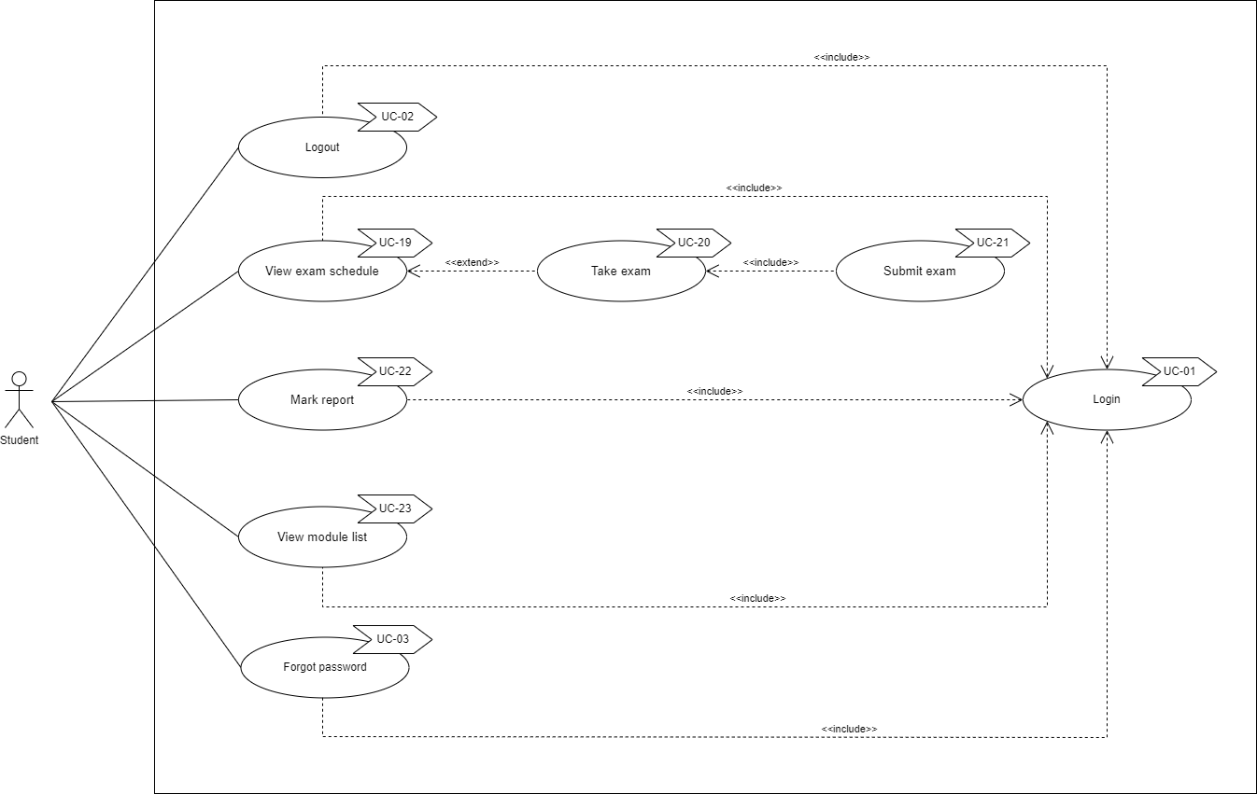
Figure 2. Use case Student

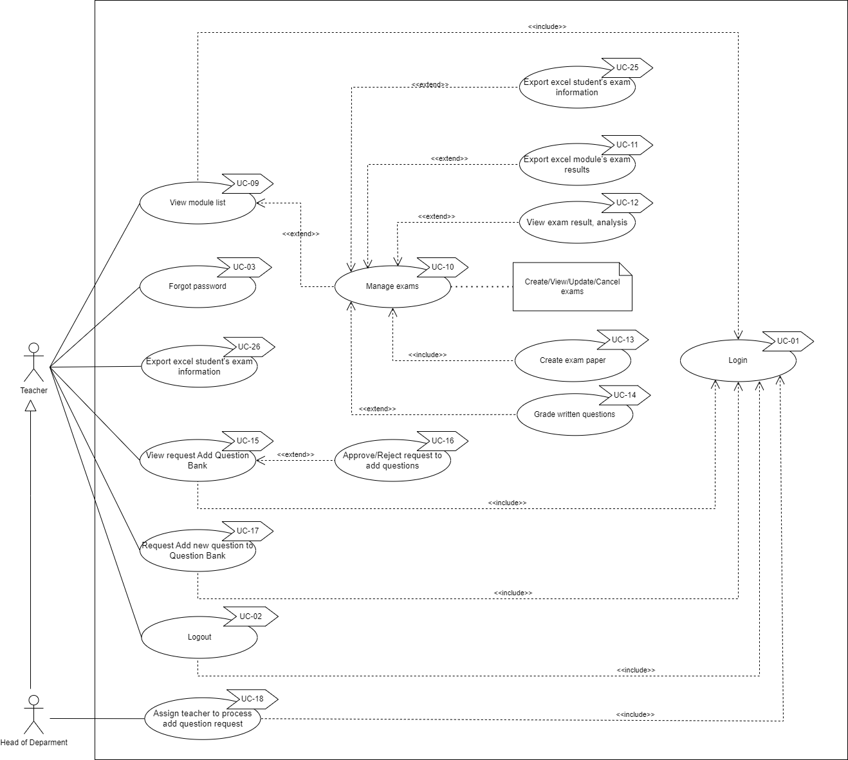
Figure 3. Use case Teacher and Head of Department

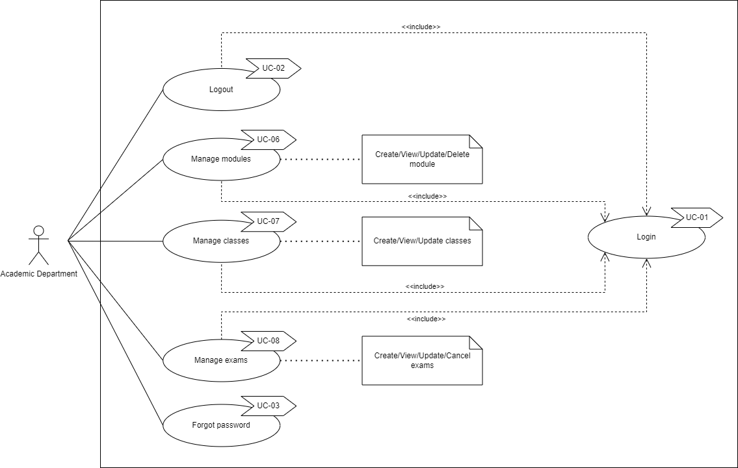
Figure 4. Use case of Academic Department

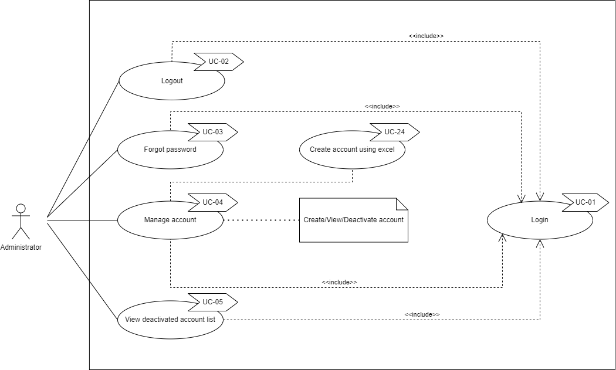
Figure 5. Use case of Administrator

b. System Actors
# | Actor | Description
1 | Administrator | Administrator can manage the system’s account.
2 | Academic Department | The Academic Department can manage classes, modules, and exams.
3 | Head of Department | The Head of Department is the same as the Teacher but is also responsible for assigning the add question bank request.
4 | Student | Student can take exams, and view mark reports.
5 | Teacher | Teacher takes responsibility for creating progress tests, grade student text answers, create requestion questions.

c. Use Cases List
ID | Use Case | Primary Actors | Secondary Actors
UC-01 | Login | Administrator, Academic Department, Head of Department, Student, Teacher
UC-02 | Logout | Administrator, Academic Department, Head of Department, Student, Teacher
UC-03 | Forgot password | Administrator, Academic Department, Head of Department, Student, Teacher
UC-04 | Manage Account | Administrator
UC-05 | View deactivated account list | Administrator
UC-06 | Manage modules | Academic Department
UC-07 | Manage classes | Academic Department
UC-08 | Manage exams | Academic Department
UC-09 | View module list | Teacher
UC-10 | Manage exams | Teacher
UC-11 | Export excel module’s exam results | Teacher
UC-12 | View exam result, analysis | Teacher
UC-13 | Create exam paper | Teacher
UC-14 | Grade written questions | Teacher
UC-15 | View request Add question bank | Teacher
UC-16 | Approve/Reject request to add question | Teacher | Student
UC-17 | Request add new question to question bank | Teacher
UC-18 | Assign teacher to process add question request | Head of Department
UC-19 | View exam schedule | Student
UC-20 | Take exam | Student
UC-21 | Submit exam | Student
UC-22 | Mark report | Student
UC-23 | View module list | Student
UC-24 | Create account by excel | Administrator
UC-25 | Export excel student's exam information | Teacher
UC-26 | Invigilate | Teacher

2.2 Authentication

a. UC-01 Login
UC ID and Name: | UC-01 Login
Created By: | KhangTD | Date Created: | 2022 Sep 28
Primary Actor: | All actor | Secondary Actors: | N/A
Trigger: | User accesses the web application to log in.
Description: | Allow users to log in to the system to be able to use the functions provided by the system
Preconditions: | PRE-01. Account has been created.  PRE-02. Account is not deactivated.
Post-conditions: | POST-01. Login successfully and direct user to the main page based on his account’s role.
Normal Flow: | - User opens the web application.  - System directs the user to the login page.  - User inputs their email and password. (see EXC-01, EXC-02)  - User clicks on the “Login” button. (see EXC-03, EXC-04)  - System directs user to the main page based on their account’s role.
Alternative Flows: | N/A
Exceptions: | EXC-01. Email or password input field is leaved empty  - System shows a message informing that the user cannot leave any input field empty.  EXC-02. Invalid email format  - System shows a popup informing that the user's email format is invalid.  EXC-03. Wrong email or password  - System shows a popup informing that the user's email or password is wrong.  EXC-04. Account is deactivated  - System shows a popup informing that the user cannot log in with this account.  EXC-05. Lost connection with the server or the internet.
Priority: | High
Frequency of Use: | Medium
Business Rules:
Other Information:
Assumptions:

b. UC-02 Logout
ID and Name: | UC-02 Logout
Created By: | KhangTD | Date Created: | 2022 Sep 30
Primary Actor: | All actor | Secondary Actors: | N/A
Description: | Allow user logs out from the system and goes back to the login page.
Trigger: | User click on the logout icon.
Preconditions: | PRE-01. User has already logged in.
Post-conditions: | POST-01. Logout user from the system and direct user to login page.
Normal Flow: | - User opens the web application.  - User logs in successfully.  - User clicks on the logout icon on the top right corner of the web application.  - System directs the user to the login page.
Alternative Flows: | N/A
Exceptions: | EXC-01. Lost connection with the server or the internet.
Priority: | High
Frequency of Use: | Low
Business Rules:
Other Information:
Assumptions:

c. UC-03 Forgot password
ID and Name: | UC-03. Forgot password
Created By: | KhangTD | Date Created: | 2022 Sep 30
Primary Actor: | All actors | Secondary Actors: | N/A
Description: | Allow user to generate a new password when they forget.
Trigger: | User click on the “Forgot Password” link on the login page.
Preconditions: | PRE-01. User already has an account in the system.
Post-conditions: | POST-01. System sends an email with a newly generated password to the user’s email address.
Normal Flow: | - User opens the web application.  - System directs the user to the login page.  - User clicks on the “Forgot Password?” link on the login page.  - System directs user to the “Forgot Password” page to allow user to input their email.  - User inputs their email. (see EXC-01, EXC-02)  - User clicks on the “Send new password” button.  - Systems shows a popup informing that an email containing a new password was sent to the user’s email address.
Alternative Flows: | N/A
Exceptions: | EXC-01. Email input field is leaved empty.  - System shows a message informing that the user cannot leave any input field empty.  EXC-02. Invalid email.  - System shows a popup informing that the user's email is invalid.  EXC-03. Lost connection with the server or the internet.
Priority: | High
Frequency of Use: | Low
Business Rules: | BR-08
Other Information:
Assumptions:

2.3 Manage

a. UC-04 Manage account
ID and Name: | UC-04 Manage account
Created By: | ThoTA | Date Created: | 2022 Sep 23
Primary Actor: | Administrator | Secondary Actors: | N/A
Description: | Allow the Administrator to perform CRUD (Create, Update, Deactivate, Read) action on account.
Trigger: | User login as Administrator.
Preconditions: | PRE-01. The account has been logged in as an Administrator account.
Postconditions: | POST-01. The message of CUD (Create, Update, Deactivate) account popup shows the success. In case of view, the system successfully shows the list of accounts.
Normal Flow: | - Open the web application.  - Log in as an Administrator.  - Action to take on the account list.  - Edit action case: Click on the [edit] button in the account the user wants to edit .  - Edit information shown on the popup.  - Click on the [save change] button to save change.  - Deactivate action case: Click on [Deactivate] button in the account user wants to deactivate.  - Confirm information shown on the popup.  - Click on [confirm] button to Deactivate.
Alternative Flows: | None
Exceptions: | EXC-01. The account has been deleted after the list account loads and before the user confirms delete (maybe conducted by another user).  EXC-02. Invalid information in edit popup.
Priority: | High
Frequency of Use: | Low
Business Rules:
Other Information:
Assumptions:

1) UC-24 Create account by excel
ID and Name: | UC-24 Create account by excel
Created By: | ThoTA | Date Created: | 2022 Sep 23
Primary Actor: | Administrator | Secondary Actors: | N/A
Description: | Create accounts by uploading an excel file containing a list of email and full name.
Trigger: | User login as Administrator.
Preconditions: | PRE-01. The account has been logged in as an Administrator account.
Postconditions: | POST-01. The popup shows that create success or show the coordination of cells that have errors in the excel file.
Normal Flow: | - Open the web application.  - Log in as an Administrator.  - Click on the [Create Account] icon on the left vertical navigation bar  - Click on the [Download template] button to download the excel template.  - Fill in the excel file.  - Click the [Create by excel] button.  - Click the [Choose file] button.  - Upload excel file.  - Click the [Submit] button.
Alternative Flows: | None
Exceptions: | EXC-01. Exception when reading file (wrong email, full name format).  EXC-01. Exception when adding account (email exist in the database).
Priority: | High
Frequency of Use: | Low
Business Rules:
Other Information:
Assumptions:

b. UC-06 Manage Modules
ID and Name: | UC-06 Manage Modules
Created By: | MinhDN | Date Created: | 2022 Sep 23
Primary Actor: | Academic department | Secondary Actors | N/A
Description: | Provide the Academic department with methods to manage modules including creating new modules, updating modules, and viewing modules.
Trigger: | Academic department accesses the web app.
Preconditions: | PRE-01. The account has been logged in as an Academic department account.
Postconditions: | POST-01. The message of creating or updating a module popup that shows the success.
Normal Flow: | - Open the web app.  - Log in as an Academic department.  - Action to take on the module list.
Alternative Flows: | N/A
Exceptions: | EXC-01. Lost connection with the server or the internet.  EXC-02. Creating a module that already exists.
Priority: | Medium
Frequency of Use: | Low
Business Rules:
Other Information:
Assumptions:

c. UC-07 Manage Classes
ID and Name: | UC-07 Manage Classes
Created By: | MinhHK | Date Created: | 2022 Sep 23
Primary Actor: | Academic department | Secondary Actors: | N/A
Description: | Provide the Academic department with a way to manage all the classes, including creating new classes, updating classes, and viewing classes.
Trigger: | Academic department access to the web app.
Preconditions: | PRE-01. The account has been logged in as an Academic department account.
Postconditions: | POST-01. The message of creating or updating a class popup that shows the success.
Normal Flow: | - Open web app.  - Log in as an Academic department.  - Action to take on the class list.
Alternative Flows: | N/A
Exceptions: | EXC-01. Lost connection with the server or the internet.
Priority: | Medium
Frequency of Use: | Low
Business Rules:
Other Information:
Assumptions:

d. UC-10 Manage Exams
ID and Name: | UC-10 Manage Exams
Created By: | MinhDN | Date Created: | 2022 Sep 23
Primary Actor: | Teacher | Secondary Actors: | N/A
Description: | Provide teachers with methods to manage examinations including creating new exams, updating exams, cancelling exams, and viewing exams.
Trigger: | Teacher access to the web app.
Preconditions: | PRE-01. The account has been logged in as a Teacher account.
Postconditions: | POST-01. The message of creating or updating an exam popup that shows the success.
Normal Flow: | - Open the web app.  - Log in as an Academic department.  - Action to take on the exams.
Alternative Flows: | N/A
Exceptions: | EXC-01. Lost connection with the server or the internet.
Priority: | High
Frequency of Use: | Medium
Business Rules:
Other Information:
Assumptions:

e. UC-08 Manage Exams
ID and Name: | UC-08 Manage Exams
Created By: | KhangTD | Date Created: | 2022 Oct 03
Primary Actor: | Academic department | Secondary Actors: | N/A
Description: | Provide the academic department with methods to manage examinations including creating, updating, viewing, and cancelling exams.
Trigger: | Academic department accesses the web app.
Preconditions: | PRE-01. User has logged in as an academic department account.
Postconditions: | POST-01. The system opens a popup showing a message about successfully creating, updating, and cancelling an exam. In the case of view, the system successfully shows the list of exams.
Normal Flow: | - Open the web application.  - Log in as an academic department.  - Take action to view, create, update or cancel exams.
Alternative Flows: | N/A
Exceptions: | EXC-01. Lost connection with the server or the internet.
Priority: | High
Frequency of Use: | Medium
Business Rules:
Other Information:
Assumptions:

2.4 View

a. UC-05 View deactivated account list
ID and Name: | UC-05 View deactivated account list
Created By: | ThoTA | Date Created: | 2022 Sep 23
Primary Actor: | Administrator | Secondary Actors: | N/A
Description: | Allow the Administrator to view a list of deactivated accounts.
Trigger: | User login as Administrator and click [Account history] icon.
Preconditions: | PRE-01. The account has been logged in as an Administrator account.
Postconditions: | POST-01. Display a list of deactivated accounts.
Normal Flow: | - Open the web app.  - Log in as an Administrator.  - Click the [Account history] icon.
Alternative Flows: | N/A
Exceptions: | EXC-01. Lost connection with the server or the internet.
Priority: | Low
Frequency of Use: | Low
Business Rules:
Other Information:
Assumptions:

b.UC-19 View Exam Schedule
ID and Name: | UC-19 View Exam Schedule
Created By: | ToanTK | Date Created: | 2022 Sep 27
Primary Actor: | Student | Secondary Actors: | N/A
Description: | Allow student to view exam schedule
Trigger: | User login as a Student and click on the [View Exam Schedule] icon on the left navigation bar
Preconditions: | PRE-01. The account has been logged in as a student account.
Postconditions: | POST-01. Display a list of exam schedules.
Normal Flow: | - Open the web app.  - Log in as a Student.  - Click on the [View Exam Schedule] icon.  - The system will show a list of the exam schedules.
Alternative Flows: | N/A
Exceptions: | EXC-01. Lost connection with the server or the internet.
Priority: | Medium
Frequency of Use: | High
Business Rules:
Other Information:
Assumptions:

c. UC-22 Mark report
ID and Name: | UC-22 Mark report
Created By: | ThoTA | Date Created: | 2022 Sep 23
Primary Actor: | Student | Secondary Actors: | N/A
Description: | Allow student to view their mark after exams have been graded.
Trigger: | User login as a Student and clicks on the [Mark Report] icon.
Preconditions: | PRE-01. The account has been logged in as a student account.
Postconditions: | POST-01. Display a list of marks of a module.
Normal Flow: | - Open the web app.  - Log in as a Student.  - Click on the [Mark Report] icon.  - The system will show a list of the module in which students have taken the exam.  - Student click on the button [View mark list] on the module student wants to view mark report.  - Display mark report.
Alternative Flows: | N/A
Exceptions: | EXC-01. Lost connection with the server or the internet.
Priority: | Medium
Frequency of Use: | High
Business Rules:
Other Information:
Assumptions:

d. UC-23 View module list
ID and Name: | UC-23 View module list
Created By: | MinhHK | Date Created: | 2022 Sep 23
Primary Actor: | Student | Secondary Actors: | N/A
Description: | Provide students with a way to view the modules that they are studying.
Trigger: | Student access to the web app.
Preconditions: | PRE-01. The account has been logged in as a Student account.
Postconditions: | POST-01. Display list of modules.
Normal Flow: | - Open the web app  - Login as a Student.  - Login successfully and click on the “Module” section.  - Redirect to the module list page.
Alternative Flows: | N/A
Exceptions: | EXC-01. Lost connection with the server or the internet.
Priority: | High
Frequency of Use: | High
Business Rules:
Other Information:
Assumptions:

e. UC-09 View module list
ID and Name: | UC-09 View module list
Created By: | MinhDN | Date Created: | 2022 Sep 23
Primary Actor: | Teacher | Secondary Actors: | N/A
Description: | Provide Teacher with a way to view the modules that they teach
Trigger: | Teacher access to the web app.
Preconditions: | PRE-01. The account has been logged in as a Teacher account.  PRE-02. The teacher has modules
Postconditions: | POST-01. Display list of modules
Normal Flow: | - Open the web app.  - Login as a Teacher.  - Login successfully and the teacher will be redirected to the module list page.
Alternative Flows: | N/A
Exceptions: | EXC-01. Lost connection with the server or the internet.
Priority: | Medium
Frequency of Use: | Medium
Business Rules:
Other Information:
Assumptions:

f. UC-12 View exam result, analysis
ID and Name: | UC-12 View exam result, analysis
Created By: | MinhHK | Date Created: | 2022 Sep 23
Primary Actor: | Teacher | Secondary Actors: | N/A
Description: | Provide Teacher with a way to view the result of an exam including all the students’ score.
Trigger: | Teacher access to the web app.
Preconditions: | PRE-01. The account has been logged in as a Teacher account.  PRE-02. The exam has been created.
Postconditions: | POST-01. Show full result of the exam successfully.
Normal Flow: | - Open the web app.  - Login as a Teacher.  - Select the module in the module list.  - Select the class associated with the module.  - Click on the “Result” button on the exam card.
Alternative Flows: | N/A
Exceptions: | EXC-01. Lost connection with the server or the internet.
Priority: | Medium
Frequency of Use: | Medium
Business Rules:
Other Information:
Assumptions:

g. UC-15 View request add question bank
ID and Name: | UC-15 View request add question bank
Created By: | KhangTD | Date Created: | 2022 Oct 05
Primary Actor: | Head of Department | Secondary Actors: | N/A
Description: | Allow the head of department views all requests to add questions to the question bank.
Trigger: | Head of department logged in to the web application by their account and click on the “Assign Request” icon on the vertical navigation bar.
Preconditions: | PRE-01. Head of department has logged in to the web application.  PRE-02. The account is not deactivated.
Postconditions: | POST-01. System displays a list of all requests to add questions to the question bank.
Normal Flow: | - Open the web application.  - Log in as a head of department. (see EXC-01)  - Click on the “Assign Request” icon on the vertical navigation bar.  - System shows the list of all requests to add questions to the question bank.
Alternative Flows: | N/A
Exceptions: | EXC-01. User logs in with the account of a different role.  - System hides the “Assign Request” icon on the vertical navigation bar.  EXC-02. Lost connection with the server or the internet.
Priority: | Low
Frequency of Use: | Low
Business Rules: | BR-02
Other Information:
Assumptions:

2.5 Exam taking

a. UC-20 Take exam
ID and Name: | UC-20 Take exam
Created By: | MinhHK | Date Created: | 2022 Sep 23
Primary Actor: | Student | Secondary Actors: | N/A
Description: | Provide Students with a way to view exam questions.
Trigger: | Student access to the web app.
Preconditions: | PRE-01. The account has been logged in as a Student account.  PRE-02. The student has an exam that is happening.
Postconditions: | POST-01. Display all the questions of the exam.
Normal Flow: | - Open the web app.  - Login as a Student.  - Student will be redirect to the exam schedule page.  - Click on the “Start” button of the exam.  - Click on the “Join room” to start the exam.
Alternative Flows: | N/A
Exceptions: | EXC-01. Lost connection with the server or the internet.
Priority: | High
Frequency of Use: | Medium
Business Rules:
Other Information:
Assumptions:

b. UC-21 Submit exam
ID and Name: | UC-21 Submit exam
Created By: | KhangTD | Date Created: | 2022 Oct 10
Primary Actor: | Student | Secondary Actors: | N/A
Description: | Allow student to submit the exam to the system and get the multiple choice mark after submitted.
Trigger: | Student click on the “Finish” button when taking the exam or when the examination time is up.
Preconditions: | PRE-01. User has logged in to the system with a student account.  PRE-02. The account is not deactivated.  PRE-03. Student takes the exam.
Postconditions: | POST-01. System informs that exam has been submitted successfully and shows the multiple choice mark.
Normal Flow: | - Open the web app.  - Login as a Student.  - Student will be redirect to the exam schedule page.  - Click on the “Start” button of the exam.  - Click on the “Join room” button to start the exam.  - Click on the “Finish” button to submit the exam.  - System directs the user to the mark report page.  - System opens a popup informing that the user has submitted the exam successfully and shows the multiple choice mark.
Alternative Flows: | After step 5 of normal flow  - System automatically submit the exam when the time is up.  - Return to step 7 of normal flow
Exceptions: | EXC-01. Submit the exam when have not answered all questions.  - System opens a popup informing that the user has some questions not answered.  - a) If user selects the submit option, then return to step 7 of normal flow.  b) Else if user selects the cancel option, then system closes the popup and allows user to continue taking the exam.  EXC-02. Lost connection with the server or the internet.
Priority: | High
Frequency of Use: | Medium
Business Rules:
Other Information:
Assumptions:

c. UC-11 Export excel module's exam result
ID and Name: | UC-11 Export excel module's exam result
Created By: | ToanTK | Date Created: | 2022 Sep 27
Primary Actor: | Teacher | Secondary Actors: | N/A
Description: | Provide Teacher with a way to view the student's mark in all exams of a module in excel.
Trigger: | Teacher access to the web app.
Preconditions: | PRE-01. The account has been logged in as a Teacher account.  PRE-02. The exam has happened.
Postconditions: | POST-01. Show full result student’s mark in all of a module successfully in excel.
Normal Flow: | - Open the web app.  - Login as a Teacher.  - Select the module in the module list.  - Select the class associated with the module.  - On the exam list page, click on the red Excel button in the top right, it will download an excel file.  - Choose location to save the file.  - Open the excel file.
Alternative Flows: | N/A
Exceptions: | EXC-01. Lost connection with the server or the internet.  EXC-02. The class associated with the module doesn’t have any exam.
Priority: | Medium
Frequency of Use: | Medium
Business Rules:
Other Information:
Assumptions:

d. UC-13 Create exam paper
ID and Name: | UC-13 Create exam paper
Created By: | ThoTA | Date Created: | 2022 Sep 23
Primary Actor: | Teacher | Secondary Actors: | N/A
Description: | Allow Teacher to create an exam paper based on question banks.
Trigger: | Users login as Teacher and click the [Create exam] icon, after creating exam successfully, the system will redirect to the Create exam paper page.
Preconditions: | PRE-01. The account has been logged in as a Teacher account.  PRE-02. The exam must be created before creating exam paper.
Postconditions: | POST-01. Display a popup to show that create exam paper successfully.
Normal Flow: | - Open the web app.  - Log in as a Teacher.  - Click the [Create exam] icon.  - Create exam [UC-10]  - Set number of multiple choice questions for each level.  - Set number of essay questions for each level.  - Choose question from question bank (optional).  - Choose [Create from picked question] button to create exam paper from question that have been picked from question bank or choose [Random from question bank] to auto create exam paper based on number of questions per level.
Alternative Flows: | N/A
Exceptions: | EXC-01. Lost connection with the server or the internet.  EXC-02. Input number of question per level is not valid number format.  EXC-03. Input number of question per level is bigger than number of question in question bank.
Priority: | High
Frequency of Use: | Medium
Business Rules:
Other Information:
Assumptions:

e. UC-14 Grade written question
ID and Name: | UC-14 Grade written question
Created By: | ToanTK | Date Created: | 2022 Sep 28
Primary Actor: | Teacher | Secondary Actors: | N/A
Description: | Allow Teacher to grade written question of student exam answer.
Trigger: | Teacher access to the web app.
Preconditions: | PRE-01. The account has been logged in as an Teacher account.  PRE-02. The exam happened.  PRE-03. Student has answered the writing question in the exam.
Postconditions: | POST-01. Student writing answer has been graded and marks has been updated.  POST-02. Popup will be showed to announce.
Normal Flow: | - Open the web app.  - Login as a Teacher.  - Select the module in the module list.  - Select the class associated with the module.  - Click on the “Result” button on the exam card.  - Click on the “Grade” icon on each row of student mark table.  - An popup appear to show student writing answer.  - Give mark in the input form.  - Click “Submit” button to submit the mark.  - An popup will be show to announce success.
Alternative Flows: | N/A
Exceptions: | EXC-01. Lost connection with the server or the internet.  EXC-02. Input mark is not valid number format.  EXC-03. Input mark is bigger than maximum mark of the writing question.
Priority: | Medium
Frequency of Use: | Medium
Business Rules:
Other Information:
Assumptions:

f. UC-25 Export excel student's exam information
ID and Name: | UC-25 Export excel student's exam information
Created By: | ToanTK | Date Created: | 2022 Sep 29
Primary Actor: | Teacher | Secondary Actors: | N/A
Description: | Provide Teacher with a way to view the students mark in an exam by excel.
Trigger: | Teacher access to the web app.
Preconditions: | PRE-01. The account has been logged in as a Teacher account.  PRE-02. The exam has happened.
Postconditions: | POST-01. Show full result of the exam successfully in excel.
Normal Flow: | - Open the web app.  - Login as a Teacher.  - Select the module in the module list.  - Select the class associated with the module.  - Click on the “Result” button on the exam card.  - Click on the red Excel button, it will download an excel file.  - Choose location to save the file.  - Open the excel file.
Alternative Flows: | N/A
Exceptions: | EXC-01. Lost connection with the server or the internet.  EXC-02. The exam does not have any student result.
Priority: | Medium
Frequency of Use: | Medium
Business Rules:
Other Information:
Assumptions:

g. UC-26 Invigilate
ID and Name: | UC-26 Invigilate
Created By: | ThoTA | Date Created: | 2022 Sep 29
Primary Actor: | Teacher | Secondary Actors: | Student
Description: | Provide teachers with a way to view student's cameras (with the help of AI) and create reports if they are cheating.
Trigger: | Teacher access to the web app.
Preconditions: | PRE-01. The account has been logged in as a Teacher account.  PRE-02. The exam has started.
Postconditions: | N/A
Normal Flow: | - Open the web app.  - Login as a Teacher.  - Click on the [Exam Proctor] button on the left vertical navigation bar  - Click on [Start] button on the exam list table
Alternative Flows: | N/A
Exceptions: | EXC-01. Lost connection with the server or the internet.
Priority: | Medium
Frequency of Use: | Medium
Business Rules:
Other Information:
Assumptions:

2.6 Manage question bank

a. UC-16 Approve/reject to add questions
ID and Name: | UC-16 Approve/reject to add questions
Created By: | MinhDN | Date Created: | 2022 Sep 23
Primary Actor: | Teacher | Secondary Actors: | N/A
Description: | Provide teachers with a way to approve or reject questions to be added into the question bank.
Trigger: | Teacher access to the web app.
Preconditions: | PRE-01. The account has been logged in as a Teacher account.  PRE-02. There is a request for the teacher to review a set of questions.
Postconditions: | POST-01. Question is either approved or rejected.
Normal Flow: | - Open the web app.  - Login as a Teacher.  - Select Question Process tab.  - Click on the button in the detail column for any request.  - Select questions to be approved.  - Click submit.
Alternative Flows: | N/A
Exceptions: | EXC-01. Lost connection with the server or the internet.
Priority: | Low
Frequency of Use: | Low
Business Rules:
Other Information:
Assumptions:

b. UC-17 Request add new question to question bank
ID and Name: | UC-17 Request add new question to question bank
Created By: | ToanTK | Date Created: | 2022 Sep 29
Primary Actor: | Teacher | Secondary Actors: | N/A
Description: | Provide teachers with a way to send request add new question to the question bank.
Trigger: | Teacher access to the web app.
Preconditions: | PRE-01. The account has been logged in as a Teacher account.
Postconditions: | POST-01. Request add new question has been sent.
Normal Flow: | - Open the web app.  - Login as a teacher.  - Select Add Question tab on the left navigation bar.  - On the add request question page, click on “Module” and “Bank” select option to decide the Module and Bank to add new question  (The default select option for “Question type” is “Multiple choice”).  - Click “Add new question” button to create input form for multiple choice questions.  - Click “Choose file” to choose the image for the question, if necessary.  - Click “Level” select option to choose the difficulty for the question.  - Input question on the big text area for the multiple choice question.  - Input answer on the small input form.  - Click “Add new answer” to create more answers, if necessary.  - Click on small radio button of the answer to choose the right answer.  - Click “Add new question” and repeat from step 5 to create more questions.  - Click on the red “Trash” icon to delete questions or answers, if necessary.  - Click “Send request” button to submit.  - Click “Confirm” on the confirmation modal to send the request.
Alternative Flows: | After step 4 of Normal Flow  - Click on “Question type” select option and choose “Text”.  - If you’re having question for the previous type, it will pop up a confirmation to delete all question of previous type. Click “Confirm”.  - Click “Add new question” button to create input form for text questions.  - Click “Choose file” to choose the image for the question, if necessary.  - Click “Level” select option to choose the difficulty for the question.  - Input question on text area for the text question content.  - Input on the text area under for the score barem.  - Click “Add new question” and repeat from step 3 to create more questions.  - Click on the red “Trash” icon to delete questions, if necessary .  - Click “Send request” button to submit.  - Click “Confirm” on the confirmation modal to send the request.
Exceptions: | EXC-01. Lost connection with the server or the internet.
Priority: | Medium
Frequency of Use: | Medium
Business Rules:
Other Information:
Assumptions:

c. UC-18 Assign teacher to process add question request
ID and Name: | UC-18 Assign teacher to process add question request
Created By: | KhangTD | Date Created: | 2022 Oct 10
Primary Actor: | Head of Department | Secondary Actors: | N/A
Description: | Allow the head of department assigns teacher to process the request add questions to the question bank.
Trigger: | Head of department logged in to the web application by their account, click on the “Assign Request” icon on the vertical navigation bar and click on the “Assign” icon on the appropriate request.
Preconditions: | PRE-01. Head of department has logged in to the web application.  PRE-02. The account is not deactivated.  PRE-03. The list of request to add questions to the question bank has a request need to be assigned.
Postconditions: | POST-01. System shows the popup informing the head of department has assigned a teacher successfully.  POST-02. System disables the “Assign” icon on the request.  POST-03. System changes the status of the request to “Assigned”.
Normal Flow: | - Open the web application.  - Log in as a head of department. (see EXC-01)  - Click on the “Assign Request” icon on the vertical navigation bar.  - System shows the list of all requests to add questions to the question bank. (see EXC-02)  - Click on the “Assign” icon on the appropriate request. (see EXC-03)  - Select a teacher to assign.  - Click “Confirm” on the confirmation popup to complete assign.
Alternative Flows: | N/A
Exceptions: | EXC-01. User logs in with the account of a different role.  - System hides the “Assign Request” icon on the vertical navigation bar.  EXC-02. Empty request list.  - System informs user that the request list is empty.  EXC-03. All requests has been assigned.  - System disables all the “Assign” icon on the request and changes the status to “Assigned”.  EXC-04. Lost connection with the server or the internet.
Priority: | Low
Frequency of Use: | Low
Business Rules: | BR-02
Other Information:
Assumptions:

3. Functional Requirements

3.1 System Functional Overview

a. Screen Flow
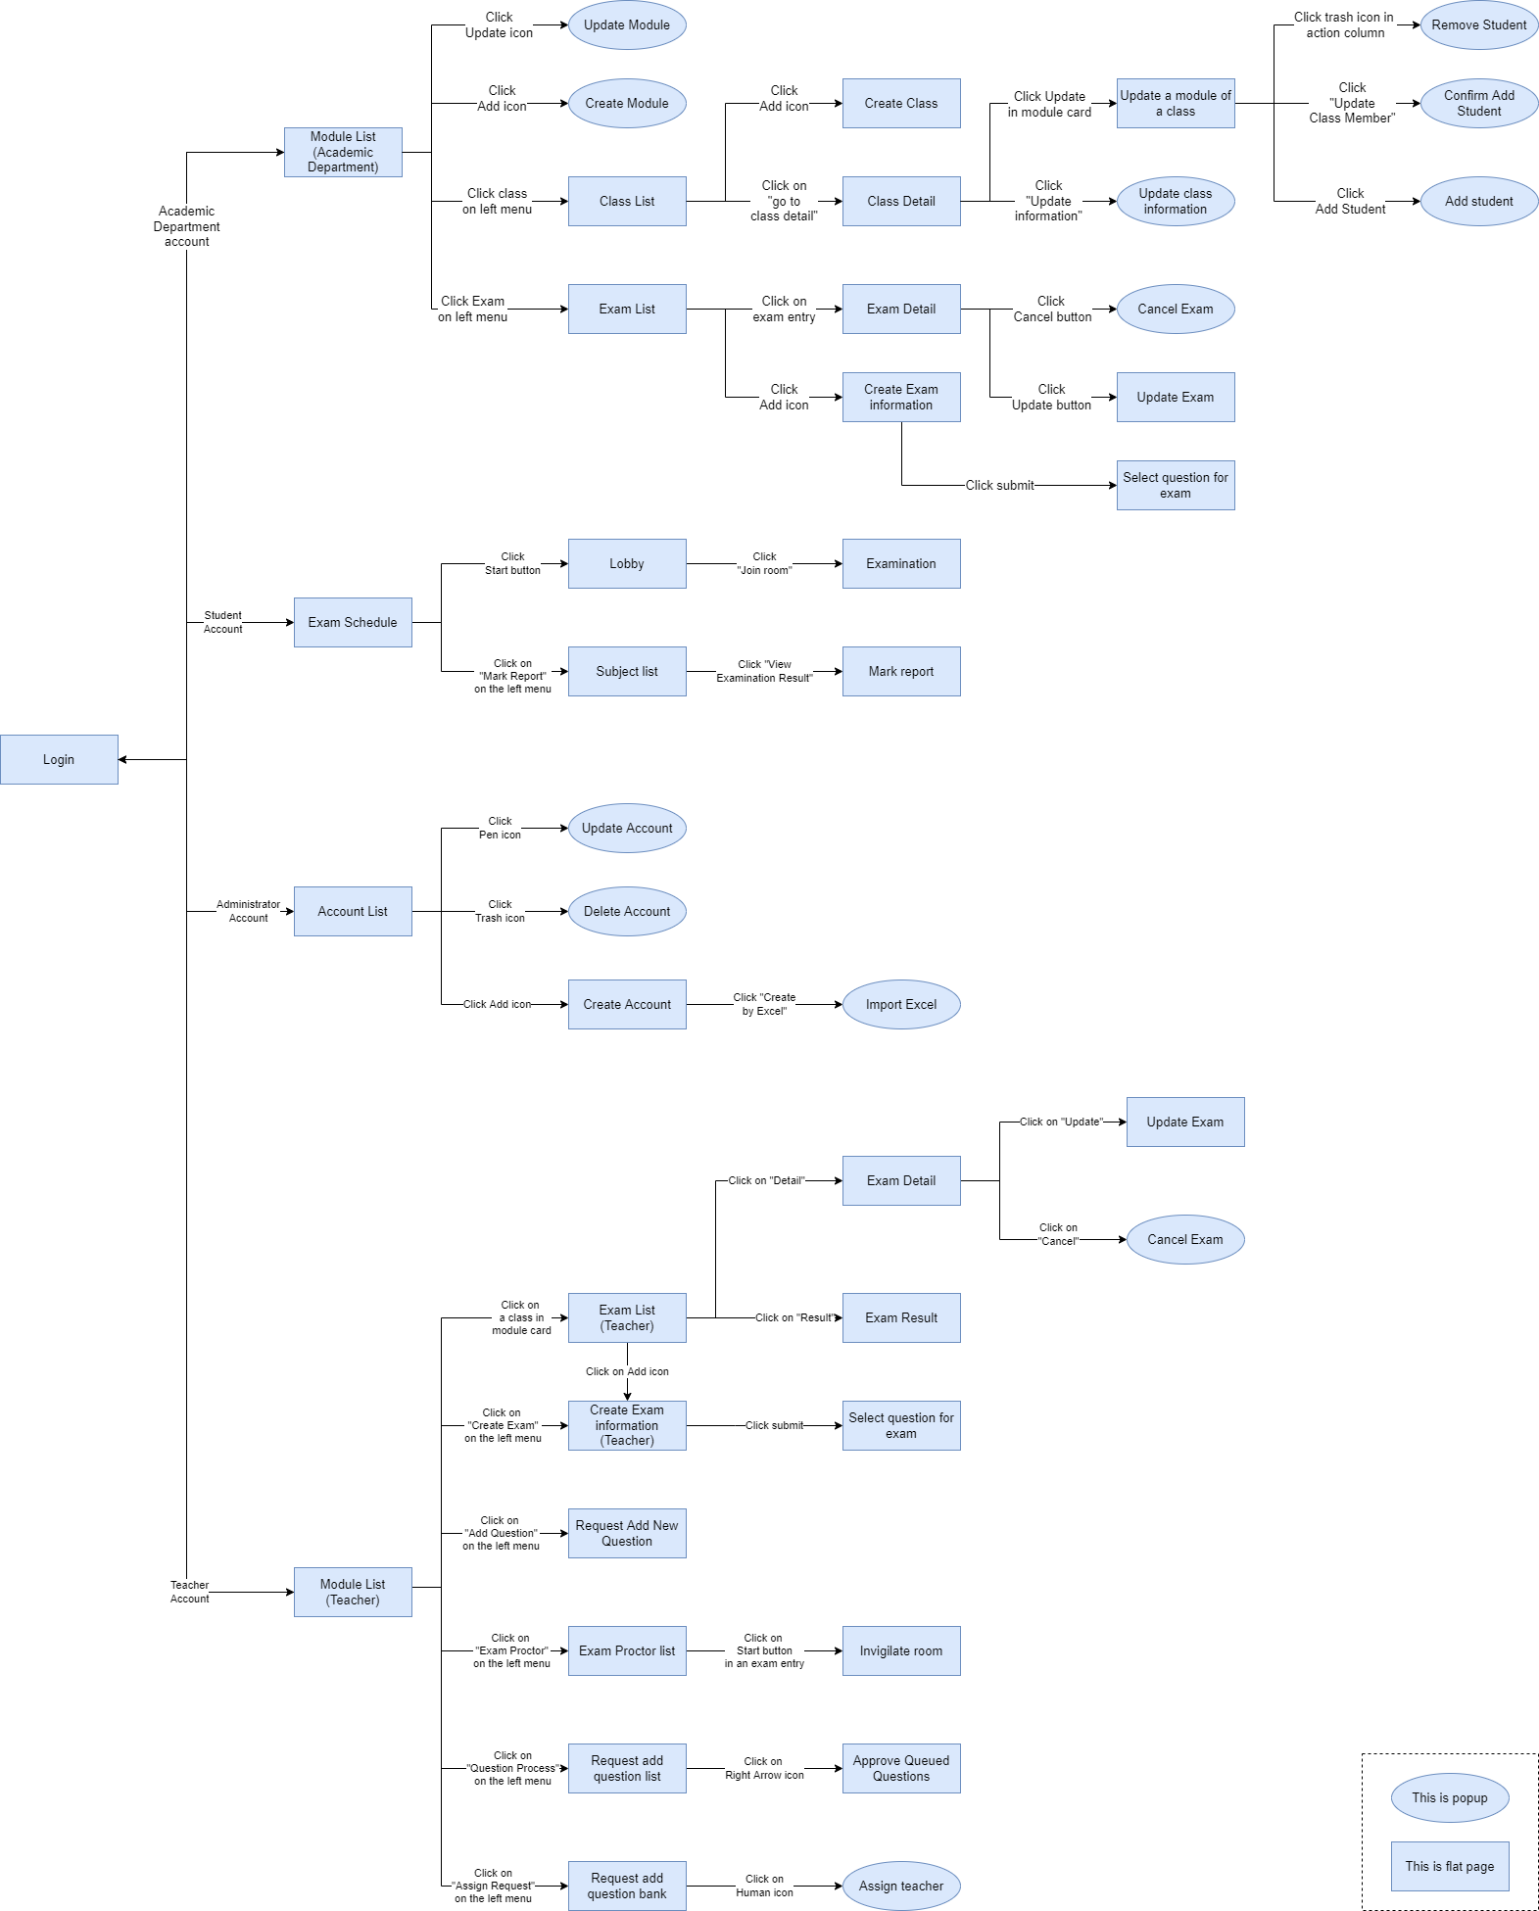
Figure 6. Screen Flow

b. Screen Details
# | Feature | Screen | Description
01 | View modules | Module List  (Academic Department) | Displays a list of modules in a table, with actions provided for each module
02 | Update Module | Update Module | Provide interface to update module’s information
03 | Create Module | Create Module | Provide interface for creating modules
04 | View Classes | Class List | Provide interface for viewing classes
05 | Create Class | Create Class | Provide interface for creating classes
06 | View Class Detail | Class Detail | Provide detailed information about classes
07 | Update class information | Update a module of a class | Provide interface to update a class’s module
08 | Update class information | Remove Student | Provide interface to remove a student from a class
09 | Update class information | Confirm add student | Provide interface to confirm adding students into a class
10 | Update class information | Add Student | Provide interface to add students into a class
11 | Update class information | Update class information | Provide interface to update class information
12 | View exams | Exam List | Provide a table listing exams
13 | View exam detail | Exam Detail | Provide detailed information about an exam
14 | Cancel Exam | Cancel Exam | Provide interface to cancel an exam
15 | Update exam | Update Exam | Provide interface to update an exam
16 | Create exam | Create Exam Information | Provide a three steps form to create information about an exam
17 | Create exam | Select question for exam | Provide interface to select questions for an exam manually, or randomise from a number of questions
18 | View upcoming exams | Exam Schedule | Provide interface to view upcoming exams of a student
19 | Taking exam | Lobby | Waiting room before entering an exam
20 | Taking exam | Examination | Provide an interface for students to take exams.
21 | View mark report | Subject List | Provide a list of subjects for student to view mark report of
22 | View mark report | Mark report | Displays mark of all exams of a subject of a student
23 | View account | Account List | Provide a list of accounts
24 | Update account | Update Account | Provide interface to update information of an account
25 | Delete account | Delete Account | Provide interface to delete an account
26 | Create account | Create Account | Provide interface to create an account
27 | Create account using excel | Import Excel | Provide interface to import accounts from an excel file
28 | View modules | Module List  (Teacher) | Provide a list of modules that the teachers teaches
29 | View exams | Exam List  (Teacher) | Provide a list of exams of a module
30 | View exam detail | Exam Detail | Display the details of an exam
31 | Update Exam | Update Exam | Provide interface to update an exam
32 | Cancel Exam | Cancel Exam | Provide interface to cancel an exam
33 | View exam result | Exam Result | Display the result of an exam
34 | Create exam | Create Exam Information  (Teacher) | Provide a four steps form to create information about an exam
35 | Create exam | Select question for Exam | Provide interface to select questions for an exam manually, or randomise from a number of questions
36 | Request Add New Question | Request Add New Question | Provide interface to post a request to add new questions into the question bank
37 | View exam proctors | Exam Proctor List | Provide interface to view a list of proctors
38 | Invigilate | Invigilate Room | Provide interface to watch over a room of examinees
39 | View Request Add Question | Request Add Question List | Display a list of add new question requests
40 | Approve questions to question bank | Approve Queued Questions | Provide interface to approve requested questions
41 | View Request Add Question | Request Add Question Bank | Provide interface to view a list of requests to add questions to question bank
42 | Assign teacher | Assign teacher | Assign a teacher to process a request to add questions

c. Screen Authorization
Screen | Academic Department | Student | Administrator | Teacher
Module List  (Academic Department) | X
Update Module | X
Create Module | X
Class List | X
Create Class | X
Class Detail | X
Update a module of a class | X
Remove Student | X
Confirm add student | X
Add Student | X
Update class information | X
Exam List | X
Exam Detail | X
Cancel Exam | X
Update Exam | X
Create Exam Information | X
Select question for exam | X
Exam Schedule |  | X
Lobby |  | X
Examination |  | X
Subject List |  | X
Mark report |  | X
Account List |  |  | X
Update Account |  |  | X
Delete Account |  |  | X
Create Account |  |  | X
Import Excel |  |  | X
Module List  (Teacher) |  |  |  | X
Exam List  (Teacher) |  |  |  | X
Exam Detail |  |  |  | X
Update Exam |  |  |  | X
Cancel Exam |  |  |  | X
Exam Result |  |  |  | X
Create Exam Information  (Teacher) |  |  |  | X
Select question for Exam |  |  |  | X
Request Add New Question |  |  |  | X
Exam Proctor List |  |  |  | X
Invigilate Room |  |  |  | X
Request Add Question List |  |  |  | X
Approve Queued Questions |  |  |  | X
Request Add Question Bank |  |  |  | X
Assign teacher |  |  |  | X
In which:
- Academic Department: The academic department is responsible for managing over students in classes, modules, and final exams.
- Student: The students of the system.
- Administrator: The people that manages over the system.
- Teacher: The teachers that uses the system.

d. Non-Screen Functions
# | Feature | System Function | Description
1 | Export marks | Export marks | Export marks of a class into an excel file

e. Entity Relationship Diagram
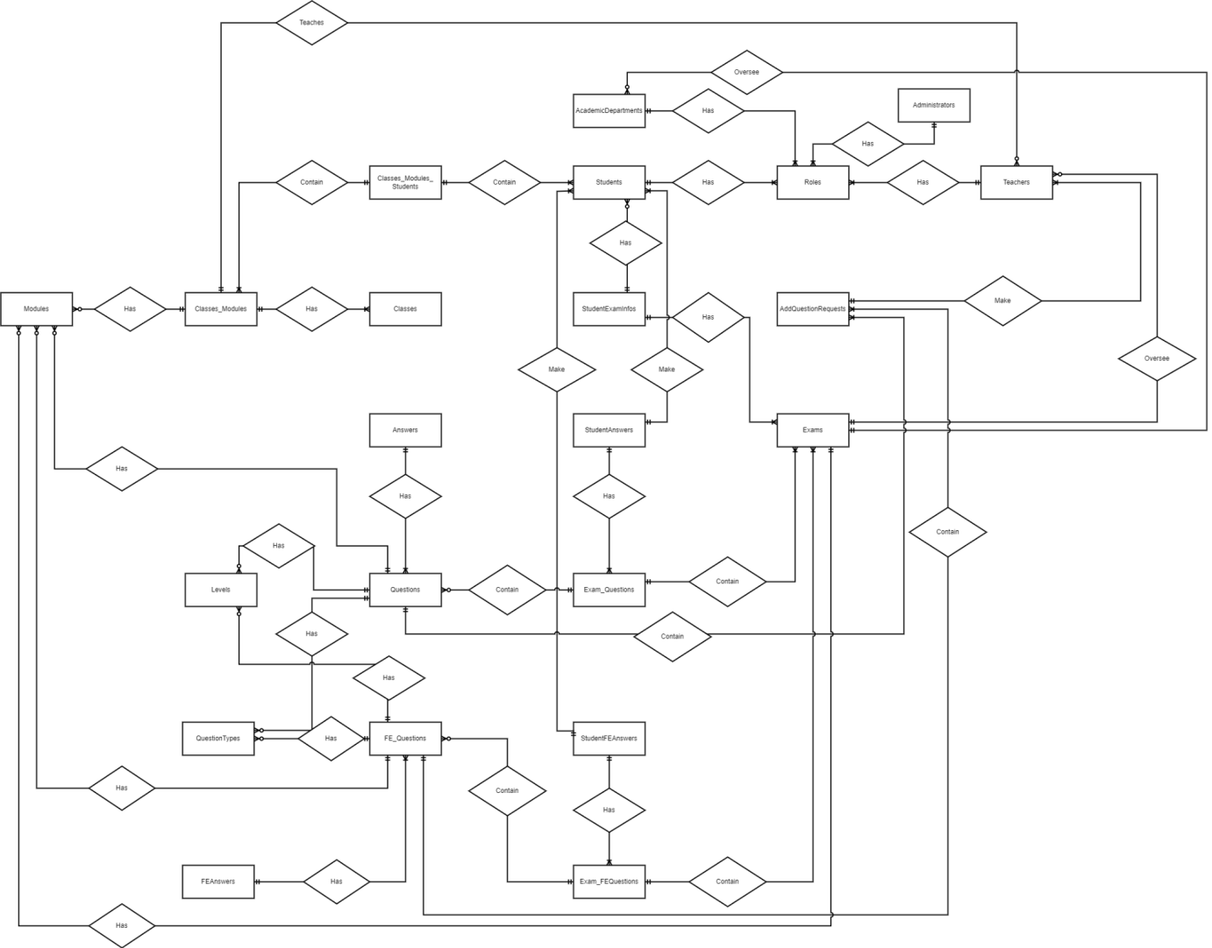
Figure 7. ERD diagram
Entities List
# | Entity | Description
1 | Academic Department | Stores information about the academic department
2 | Administrator | Stores information about the administrator
3 | Classes_Modules_Students | Stores information about which student studies in which combination of class and module
4 | Students | Stores information about the students
5 | Roles | Stores information about roles in the system
6 | Teachers | Stores information about the teachers
7 | Modules | A module is a unit of study
8 | Classes_Modules | Stores information about which class has which modules
9 | Classes | Stores information about the classes
10 | StudentExamInfos | Stores information relating to which student takes which exam
11 | AddQuestionRequests | Stores requests to add questions in to the question bank
12 | Answers | Stores the answers of multiple choice questions
13 | StudentAnswers | Stores the answer that the student gave during an exam
14 | Exams | Stores the information about exams
15 | Levels | Stores the different level of difficulty of a question
16 | Questions | Stores information about questions
17 | ExamQuestions | Stores the questions that was used for each exam
18 | QuestionTypes | Stores the types of question
19 | FE_Questions | Stores information about final exam questions
20 | StudentFEAnswers | Stores the answers that the student gave during a final exam
21 | FEAnswers | Stores the answers of multiple choice questions used specifically for final exam
22 | Exam_FEQuestions | Stores the questions that was used for final exams

3.2 Authentication

a. Login
- Triggering a function: Go to the link “https://examedu.netlify.app/” to access the login page.
- Description of the function: Allow the user to log in to the web application to be able to use all functions of the account’s role.
- Details of the function:
- Normal execution case: Login successfully and direct user to the main page based on his account’s role.
- Abnormal execution case: If the user leaves the email or password input field empty and clicks the “Login” button, an error will be displayed (Figure 9). If the user inputs invalid email format, an error will be displayed (Figure 10). If the user inputs the wrong email or password, an error will be displayed (Figure 11). If the user logs in by a deactivated account, an error will be displayed (Figure 12).
- Layout of the screen:
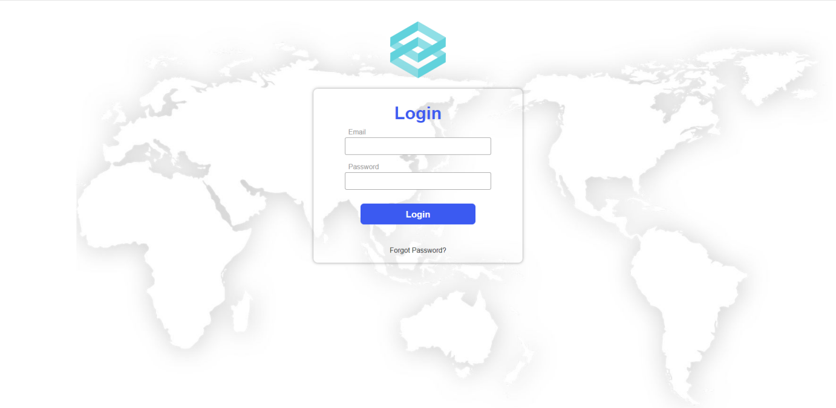
Figure 8. The login page
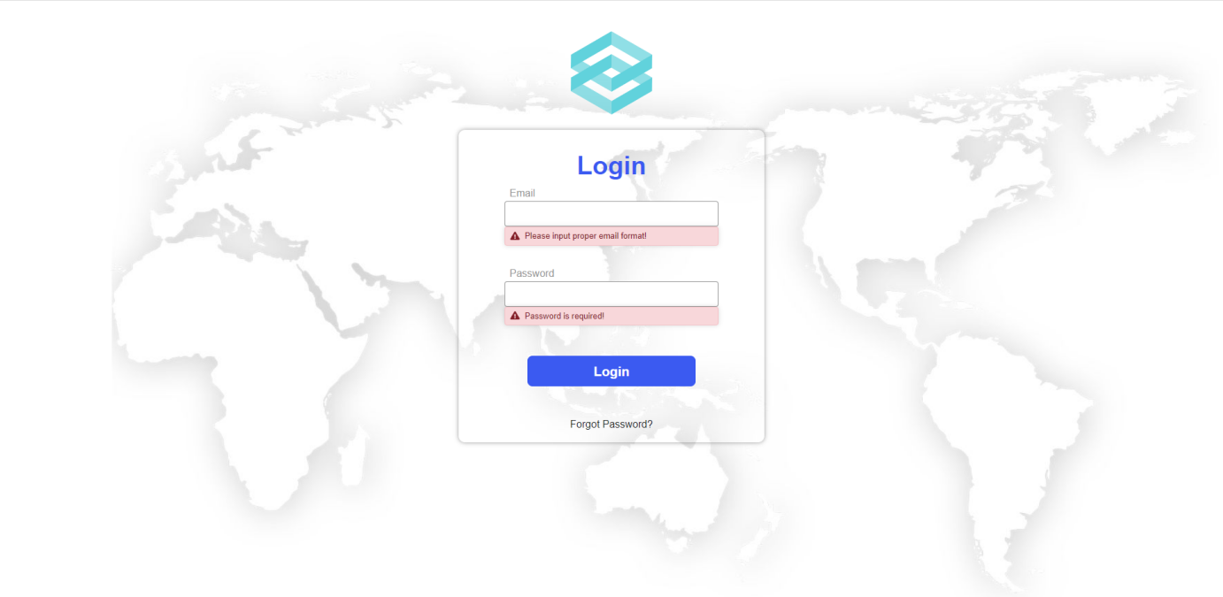
Figure 9. Error displayed when user does not inputs
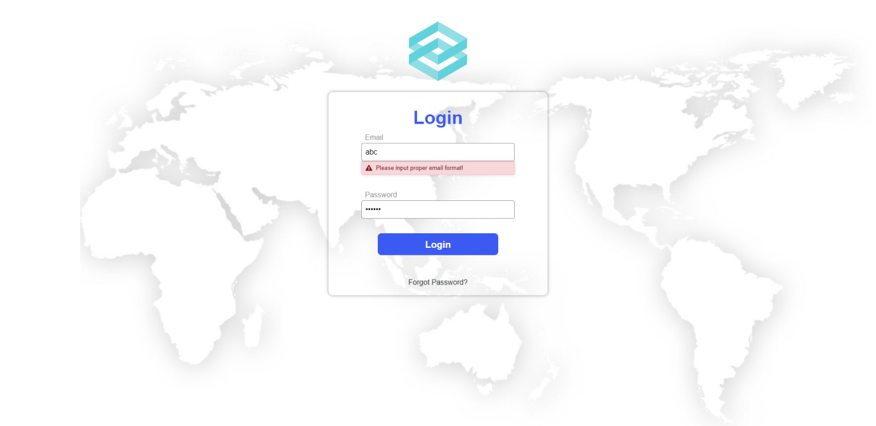
Figure 10. Error displayed when user inputs invalid email format
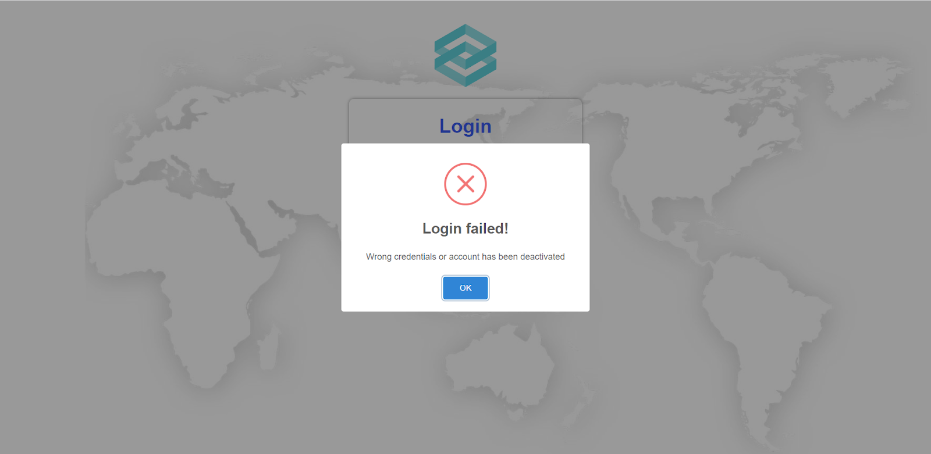
Figure 11. Error displayed when user inputs wrong email or password

Figure 12. Error displayed when user logs in with a deactivated account

b. Logout
- Triggering a function: Login successfully and click on the logout icon on the top right corner of the web application (Figure 13).
- Description of the function: Allow the user to log out from the system and go back to the login page.
- Details of the function:
- Normal execution case: Logout successfully and direct user to the login page.
- Abnormal execution case: Loss of connection.
- Layout of the screen:
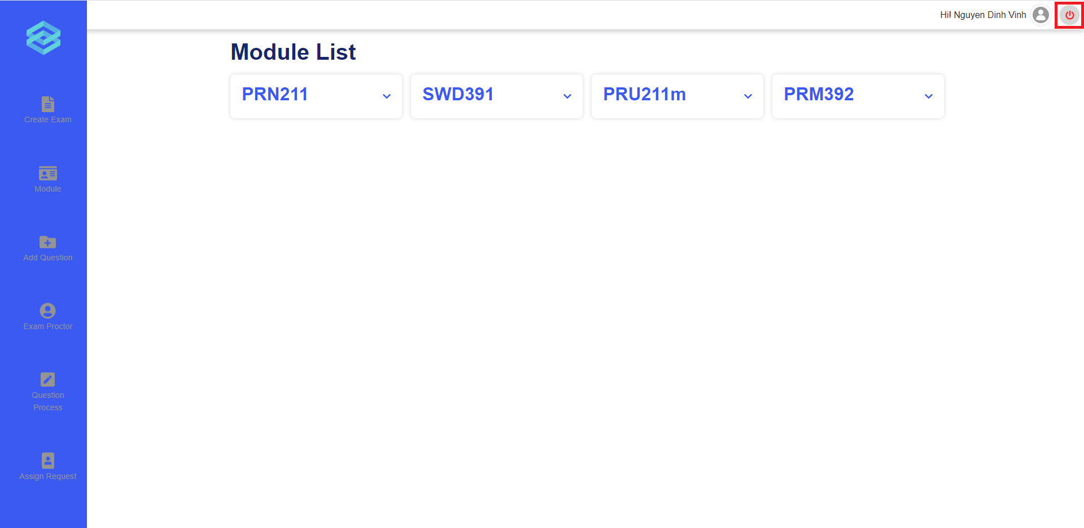
Figure 13. The logout icon

c. Forgot password
- Triggering a function: Click on the “Forgot Password?” link on the login page (Figure 14).
- Description of the function: Allow users to generate a new password when they forget the current password.
- Details of the function:
- Normal execution case: System sends an email with a newly generated password to the user’s email address.
- Abnormal execution case: If the user leaves the email input field empty and clicks the “Get New Password” button, an error will be displayed (Figure 17). If the user inputs invalid email format, an error will be displayed (Figure 18). If the user inputs email does not exist in the system, an error will be displayed (Figure 19).
- Layout of the screen:
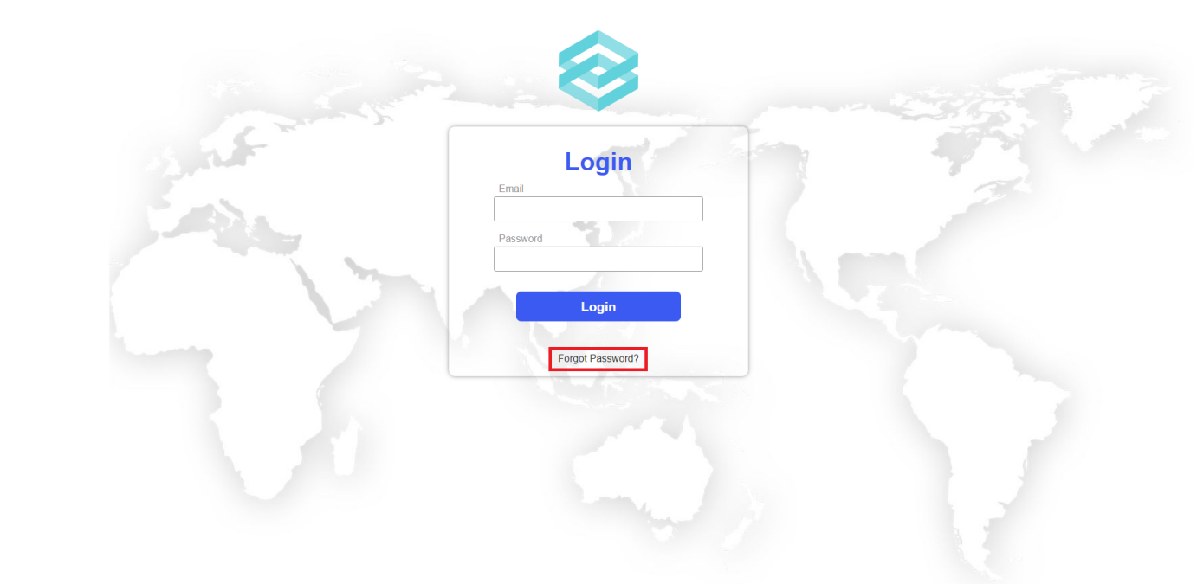
Figure 14. The “Forgot Password?” link
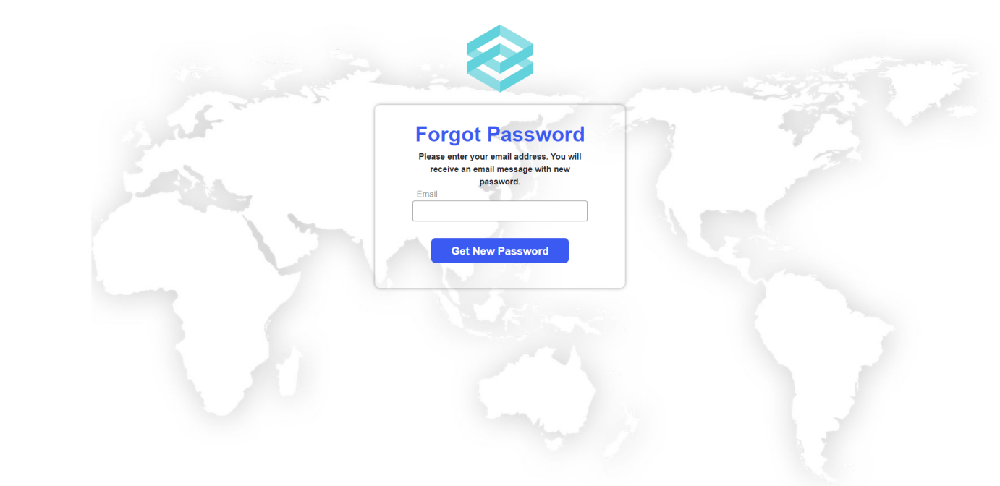
Figure 15. The forgot password page
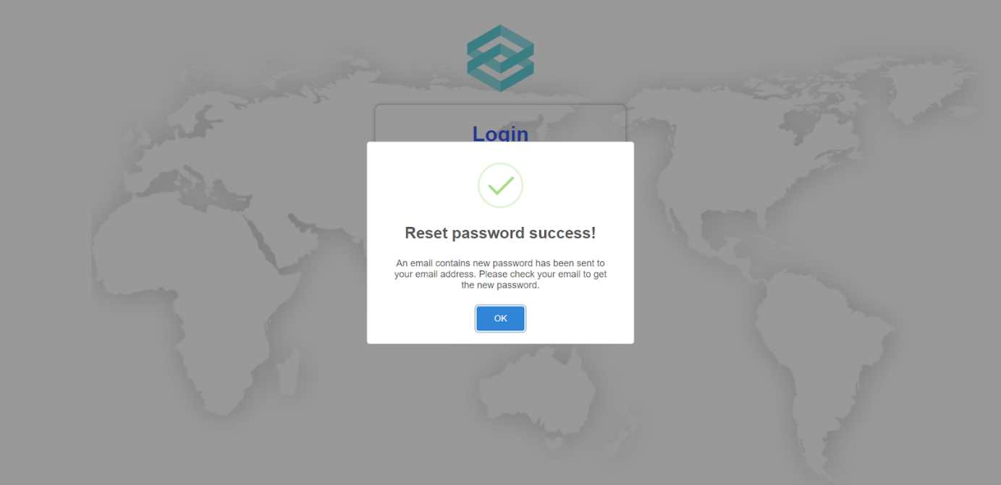
Figure 16. The reset password success message
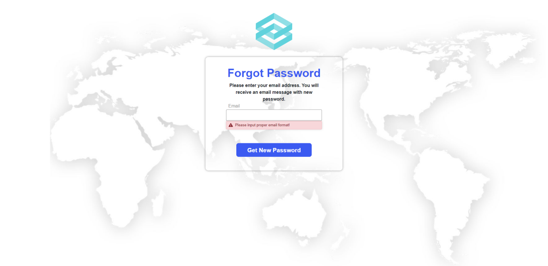
Figure 17. Error displayed when user does not input
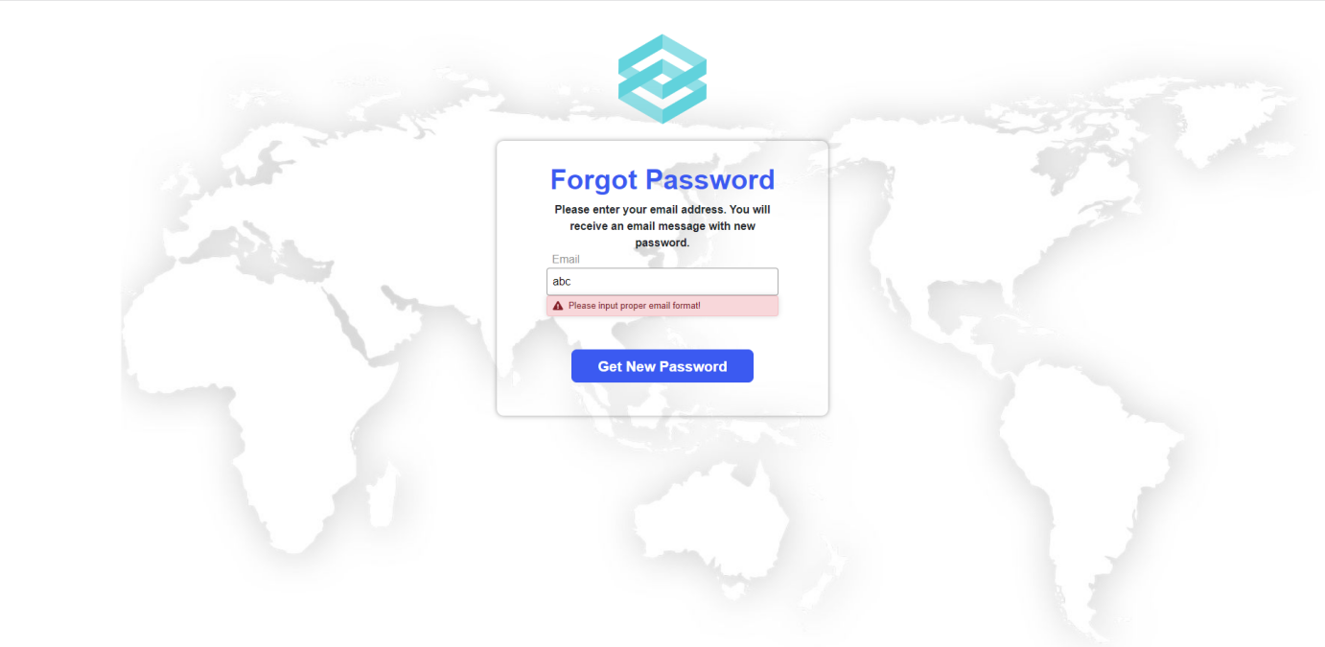
Figure 18. Error displayed when user inputs invalid email format
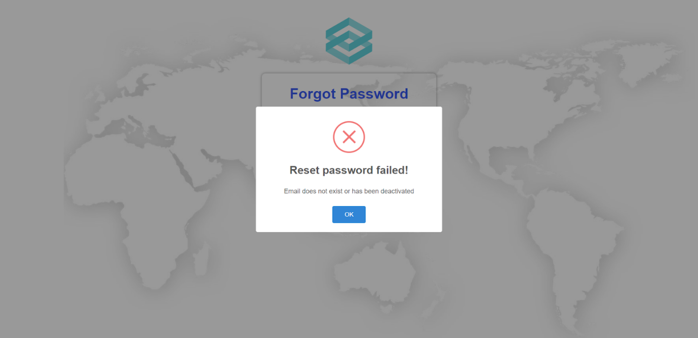
Figure 19. Error displayed when user inputs email not exist

3.3 Role Administrator

a. Manage account
- Triggering a function: Login as an Administrator successfully.
- Description of the function: An Administrator user is allowed to create accounts, edit basic account information (full name, email), deactivate account, and view account list.
- Details of the function:
  - Normal execution case: Successfully, an Administrator user has access to the account list page (Figure 20) and on each account, has access to update account information(full name, email), deactivate account. Administrator also has access to the create account page (Figure 23), has access to the create account function.
- Layout of the screen:
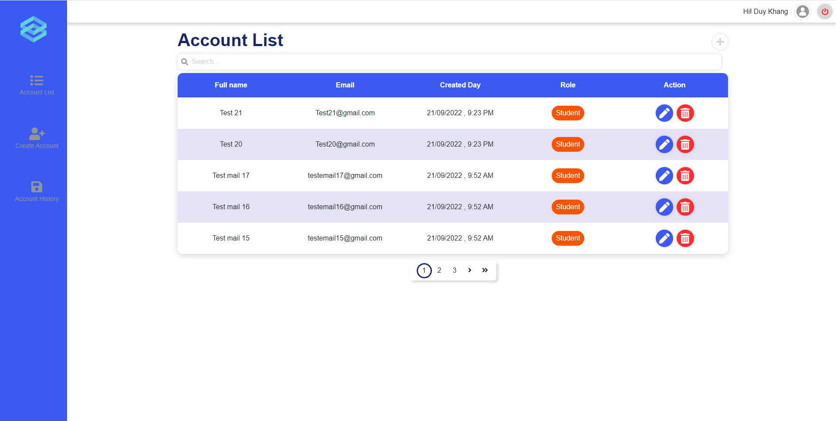
Figure 20. Manage account
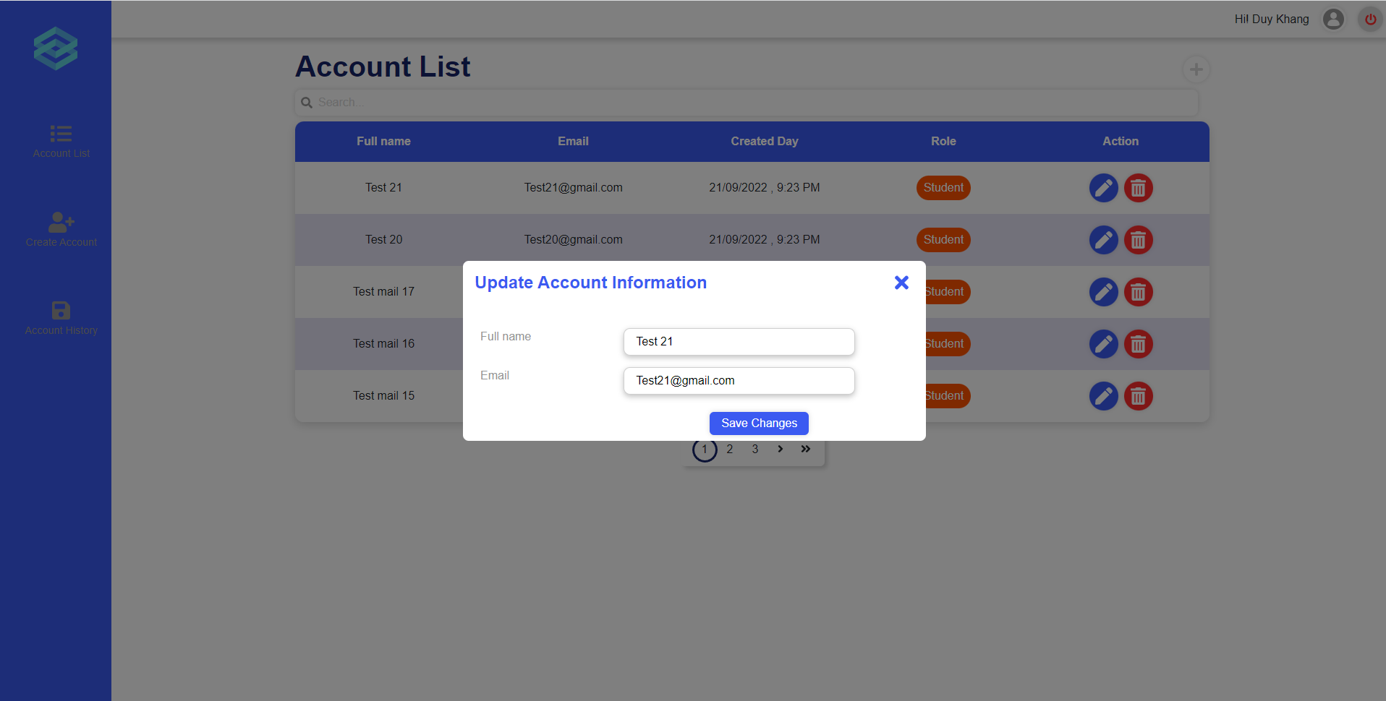
Figure 21. Update account
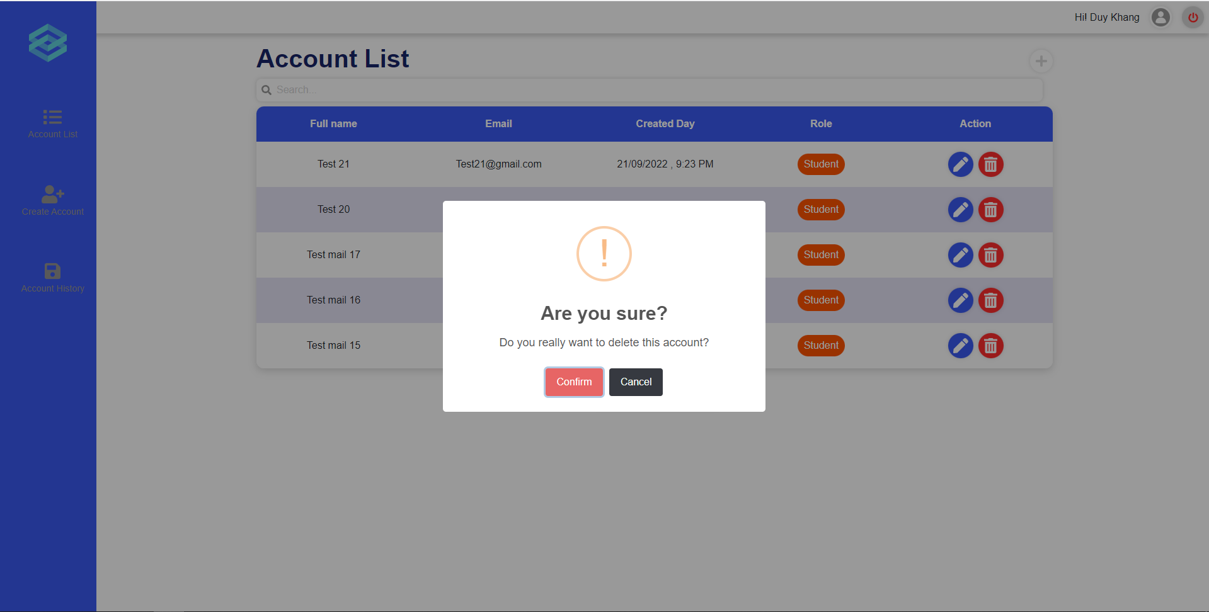
Figure 22. Delete account
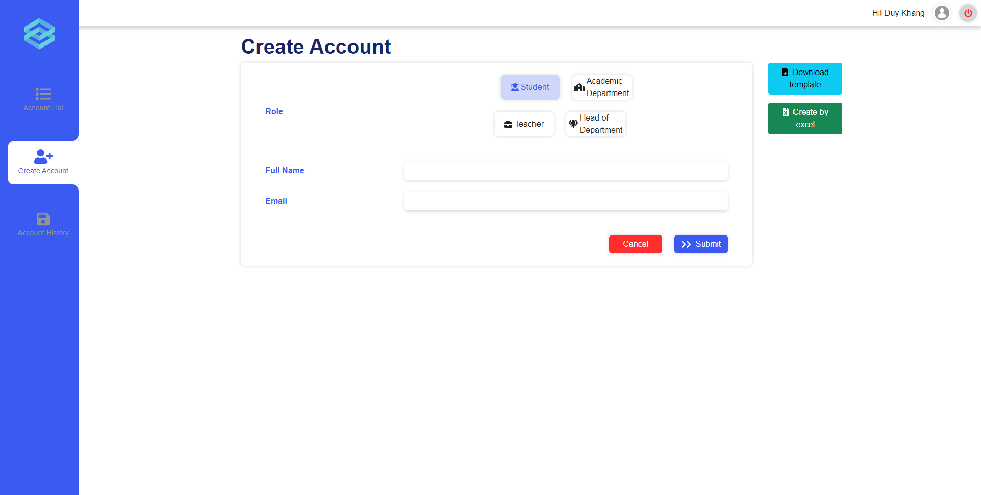
Figure 23. Create account

b. View deactivated account
- Triggering a function: Login as an Administrator successfully, click on section “Account history”.
- Description of the function: an Administrator user is allowed to view a list of deactivated accounts.
- Details of the function:
  - Normal execution case: Successfully, an Administrator user has access to the deactivated account list page (Figure 24).
- Layout of the screen:
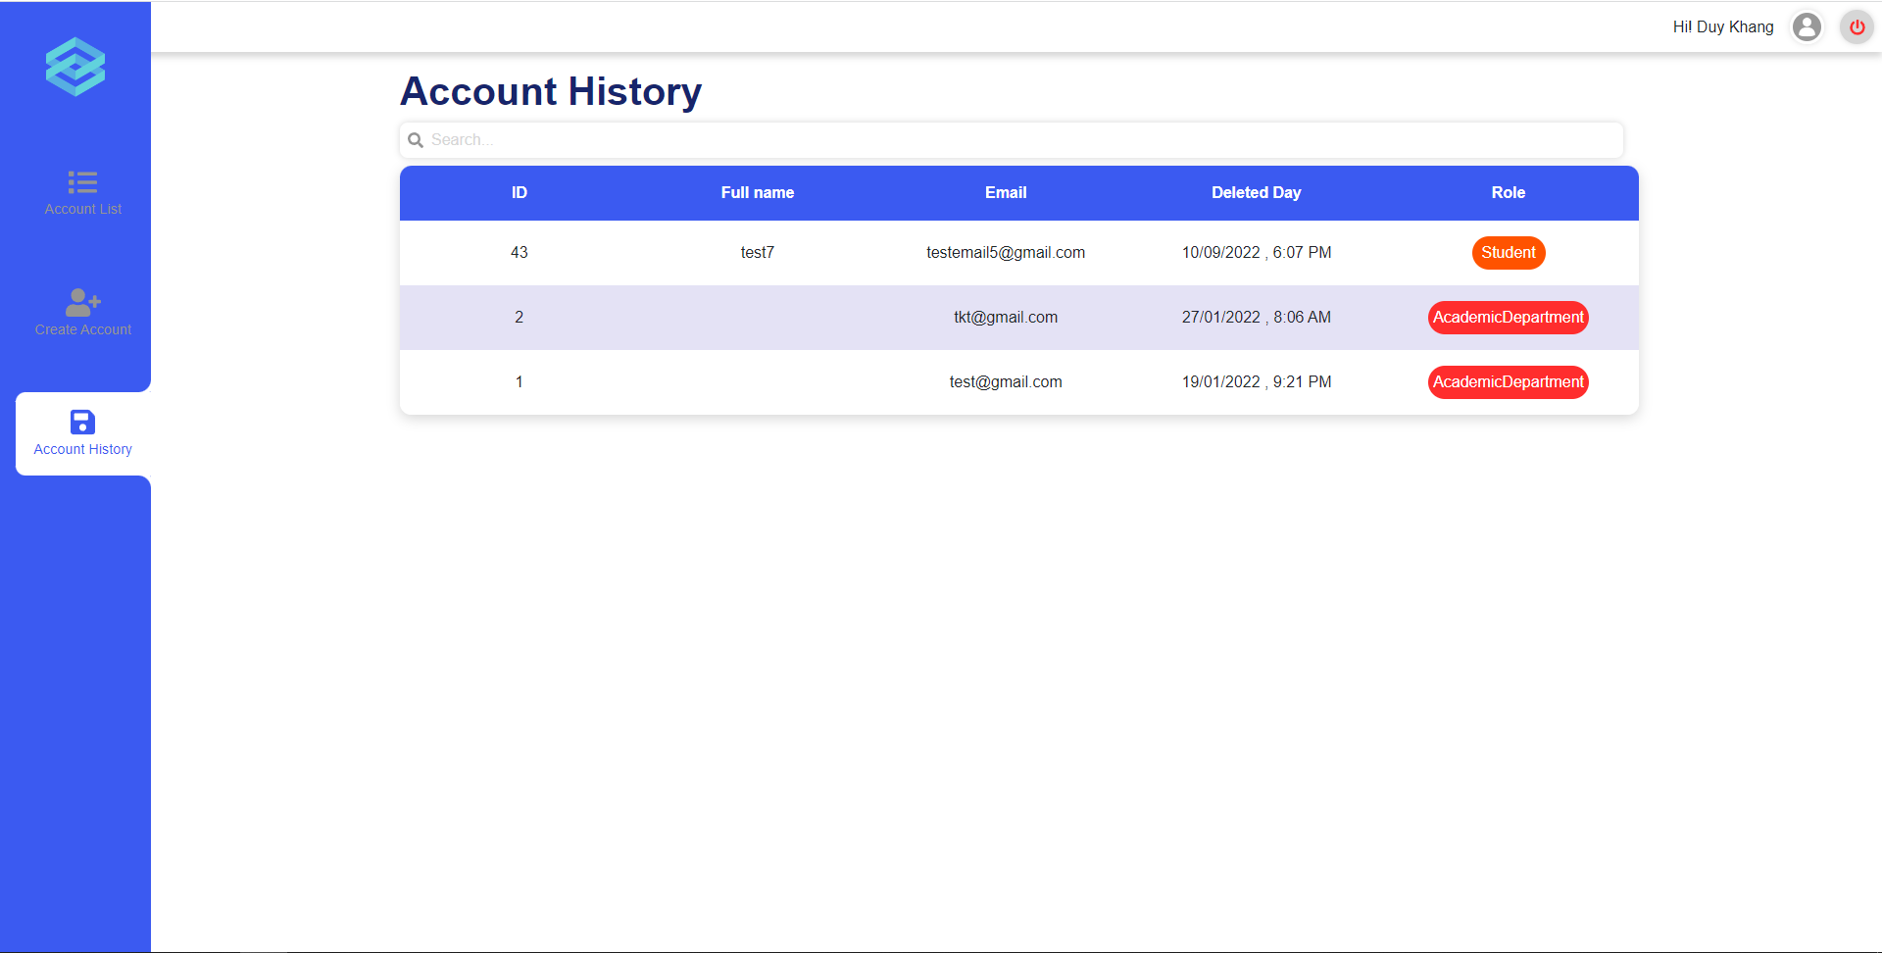
Figure 24. Deactivated account list

c. Create accounts by excel
- Triggering a function: Login as an Administrator successfully, click on section “Create account” (Figure 25), and click on the button [Create by excel].
- Description of the function: An Administrator user is allowed to create accounts by uploading excel files.
- Details of the function:
  - Normal execution case: Successfully, an Administrator user has access to the create accounts by excel function.
- Layout of the screen:
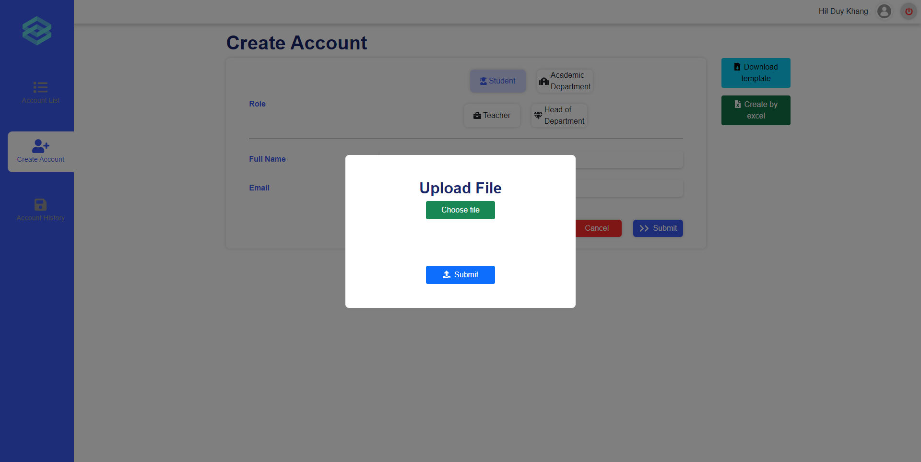
Figure 25. Create accounts by excel

3.4 Role Academic department

a. Manage modules
- Triggering a function: Login successfully, click on the plus icon (Figure 26), a popup will appear allowing you to input module’s code and name, then click on “Confirm” (Figure 27), a popup will appear asking if you want to continue or not (Figure 28), click “Yes” to create or cancel to stop the creation process. To update a module, click on the edit icon on the module you want to update (Figure 29), a popup will appear allowing you to input the updated module’s name (Figure 30), click “Confirm” (Figure 31) to continue or click cancel to stop the update.
- Description of the function: an Academic Department user is allowed to manage modules. including view module list, create, update module information.
- Details of the function:
  - Normal execution case: Successfully, an Academic Department user has access to the Module List page and on each module, has access to update module information. They also have access to creating a new module.
  - Abnormal execution case: Loss of connection.
- Layout of the screen:
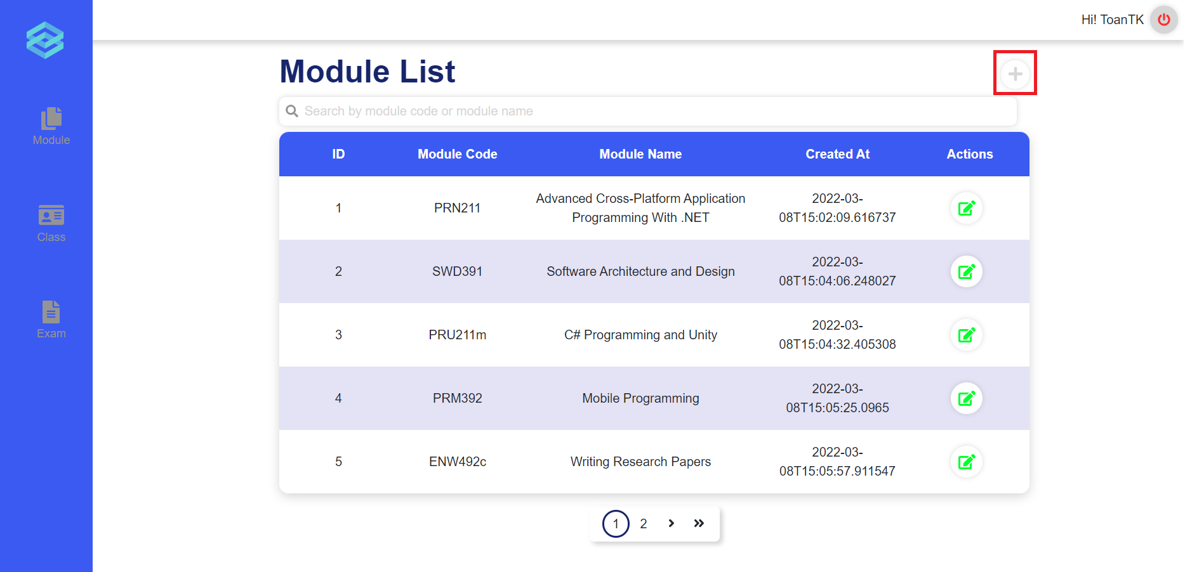
Figure 26. Module List
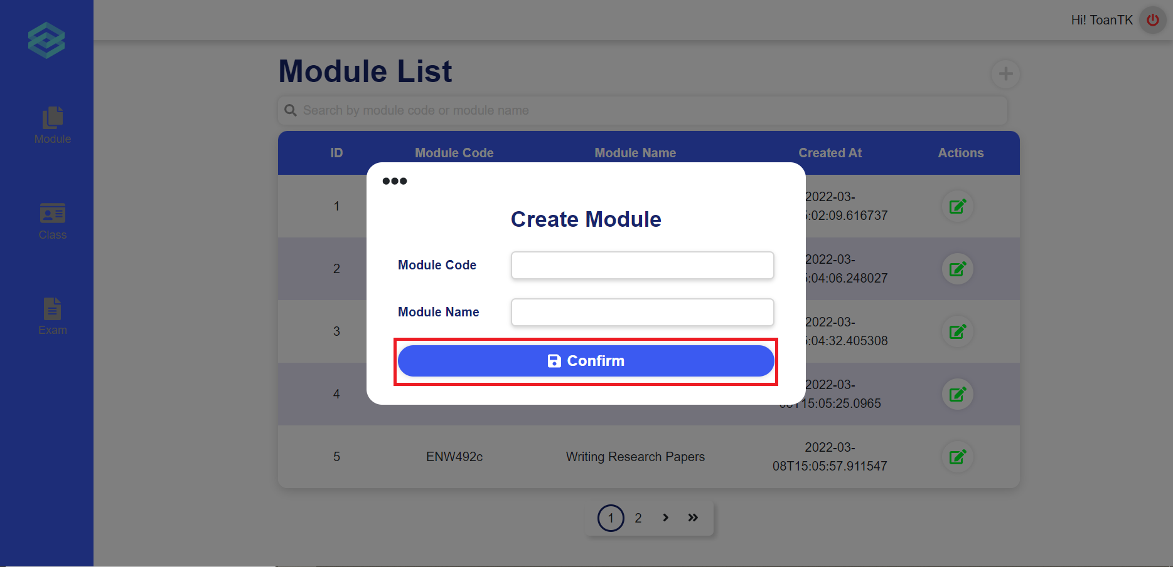
Figure 27. Create module
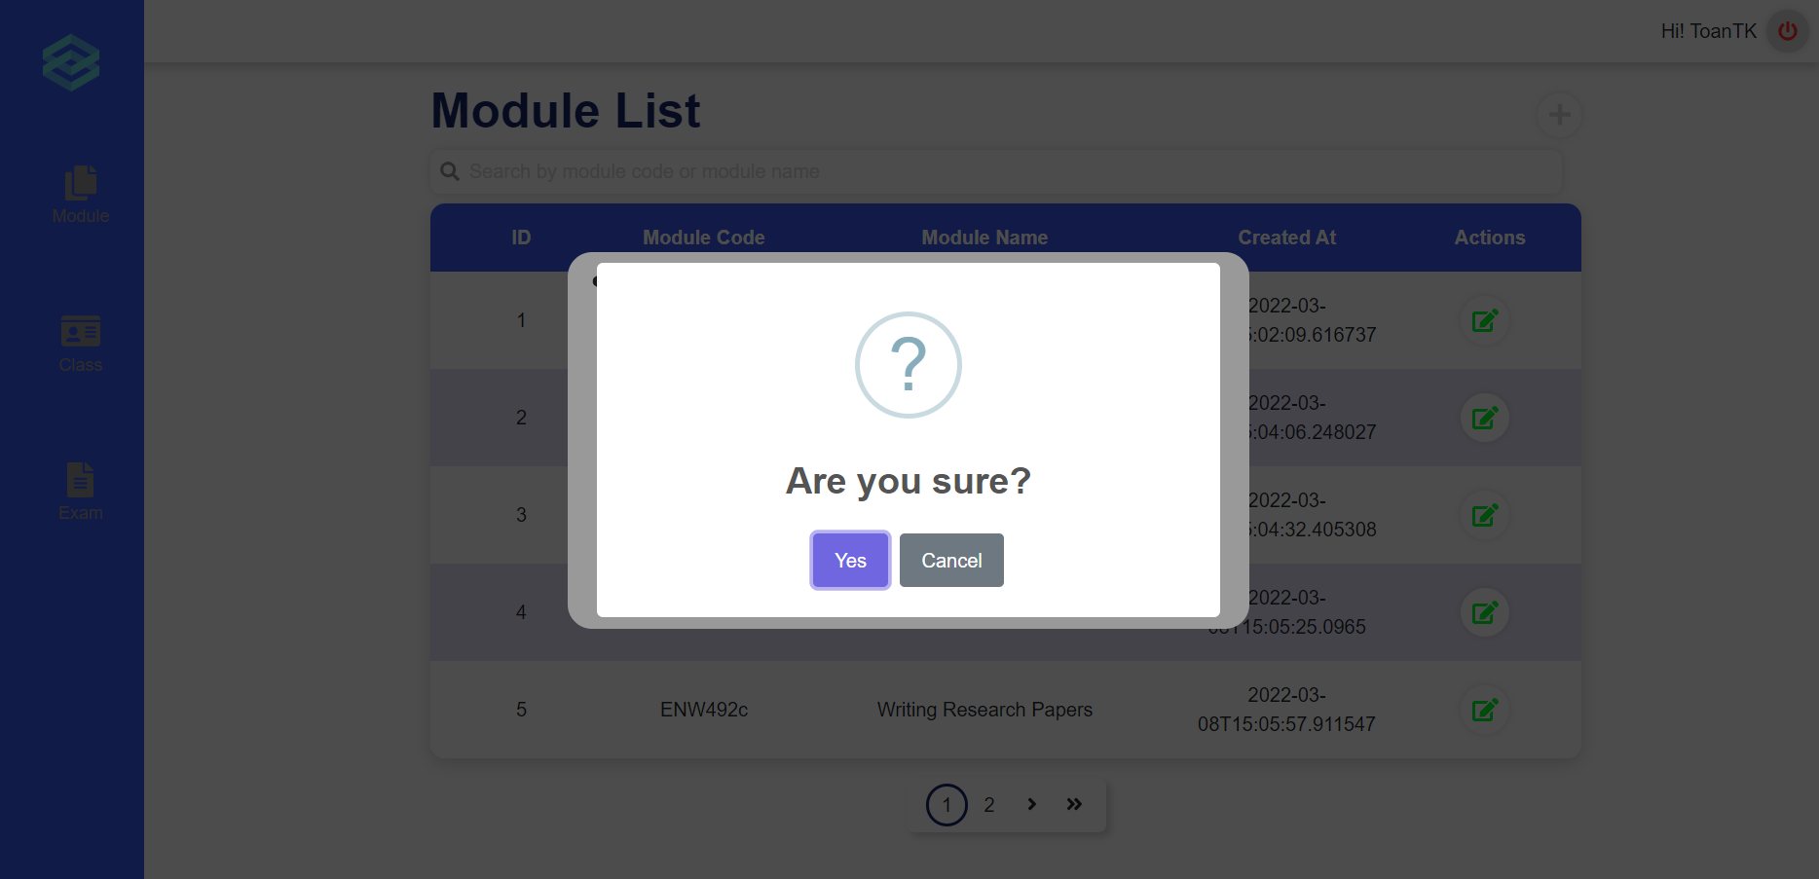
Figure 28. Confirmation message
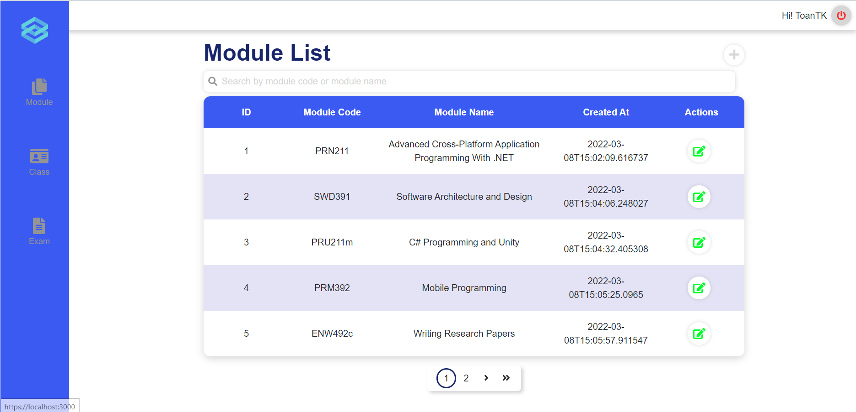
Figure 29. Module List
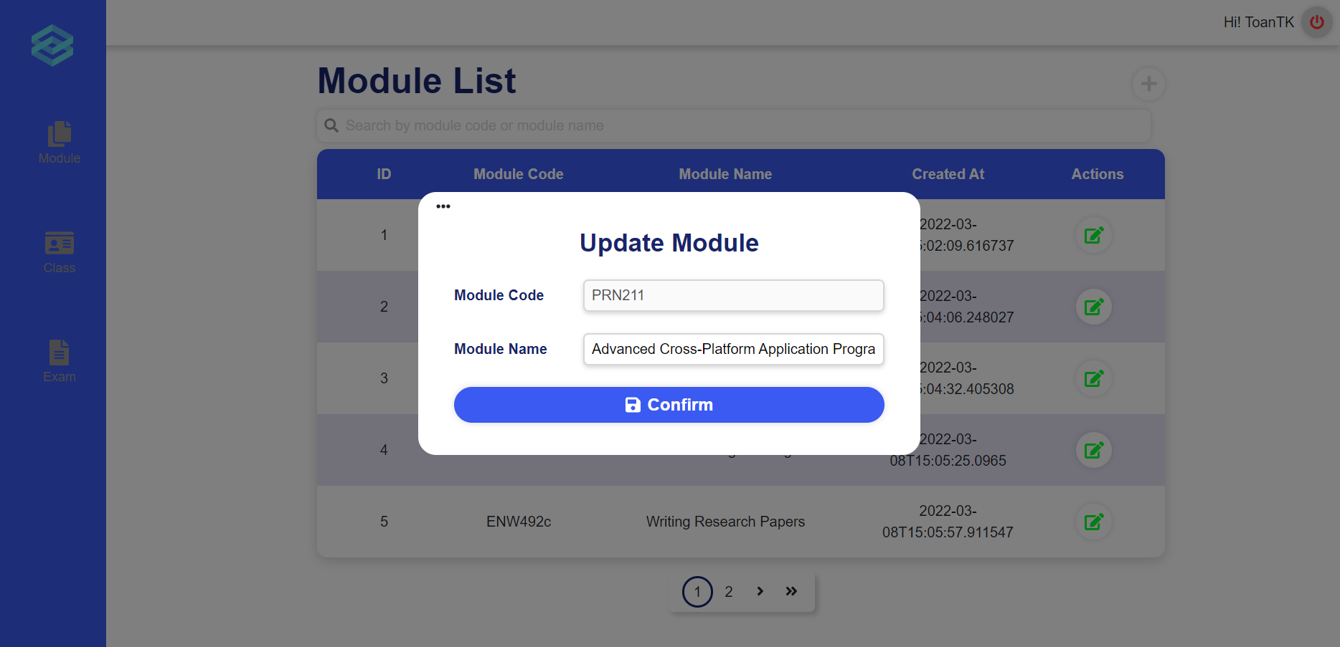
Figure 30. Update module
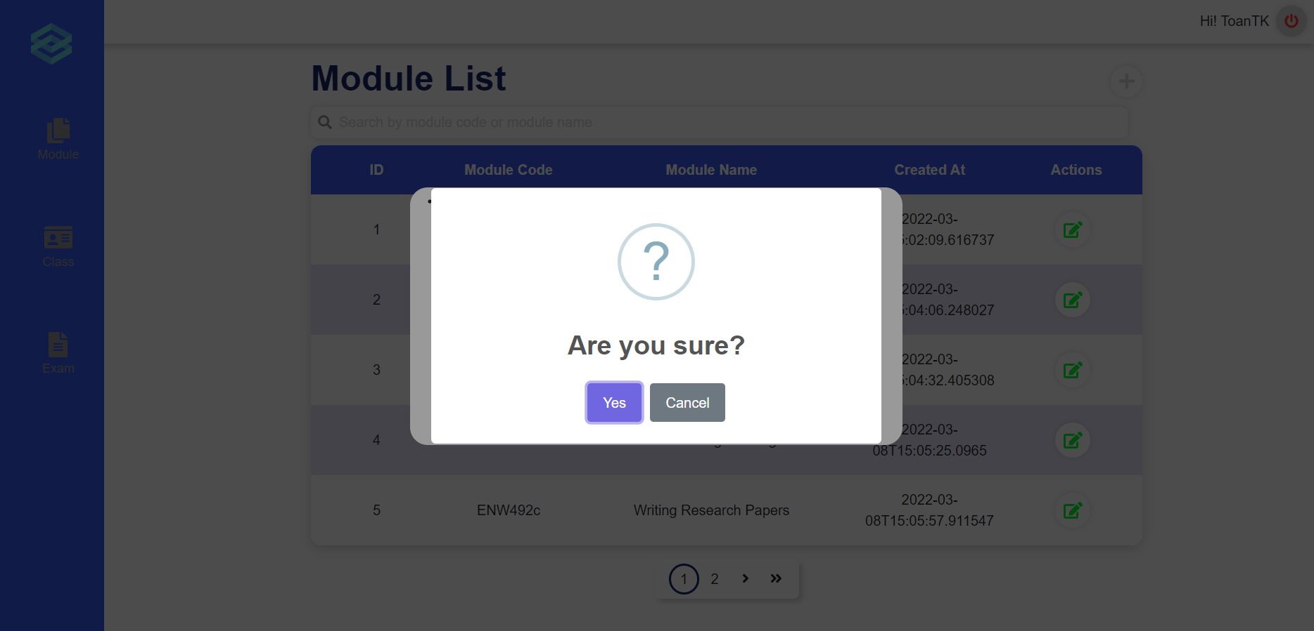
Figure 31. Confirmation message

b. Manage classes
- Triggering a function: Login successfully, click on section “Class” (Figure 32), get to the Class List Page, then click on “Go to class detail” (Figure 33) on each class.
- Description of the function: an Academic Department user is allowed to manage class. including view class list, create, update class information and update module of this class.
- Details of the function:
  - Normal execution case: Successfully, a Academic Department user have access to the Class List page and on each class, have access to update class information and update module of this class (Figure 35), or can click on the plus icon to create a new class by filling in the multi-step form (Figure 34).
- Layout of the screen:
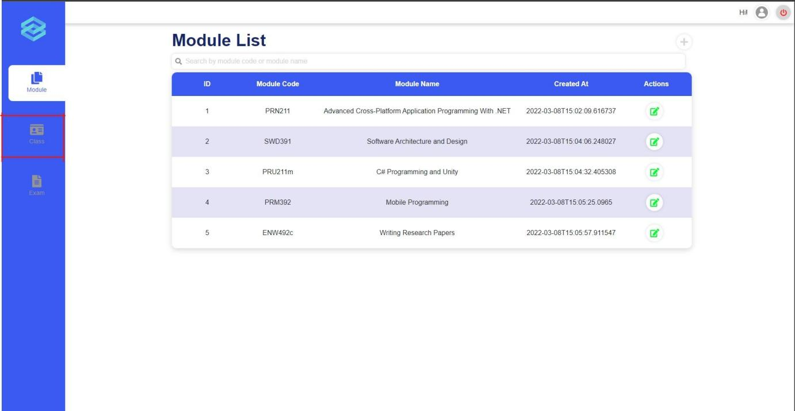
Figure 32. Manage Classes
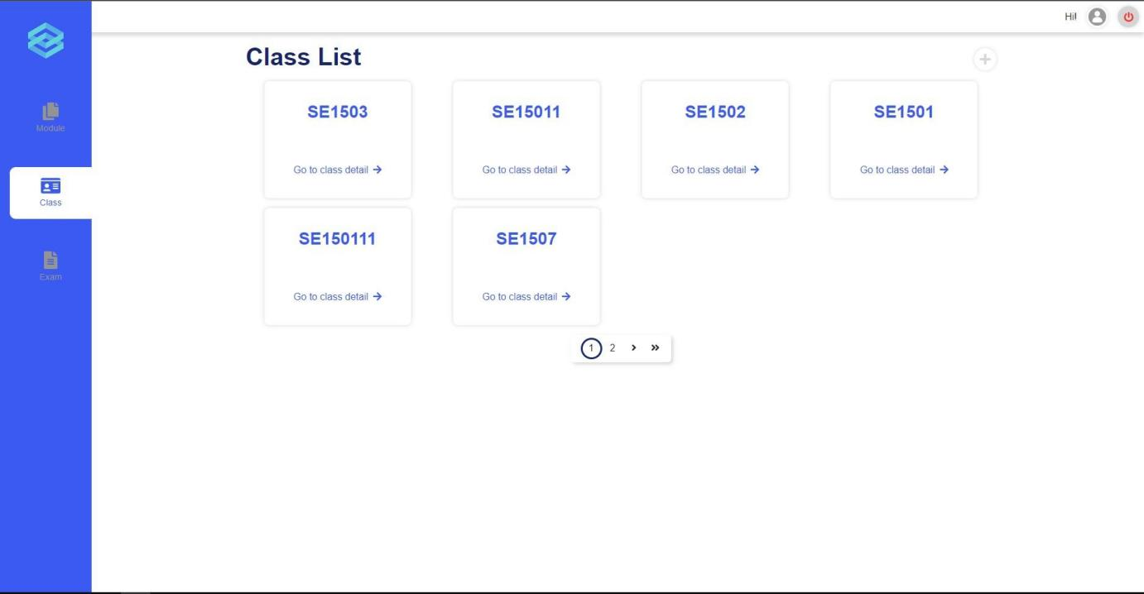
Figure 33. Class List
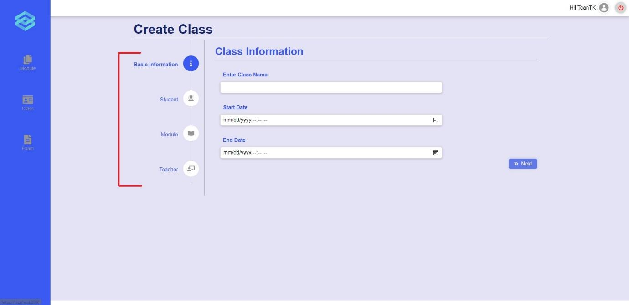
Figure 34. Create class form
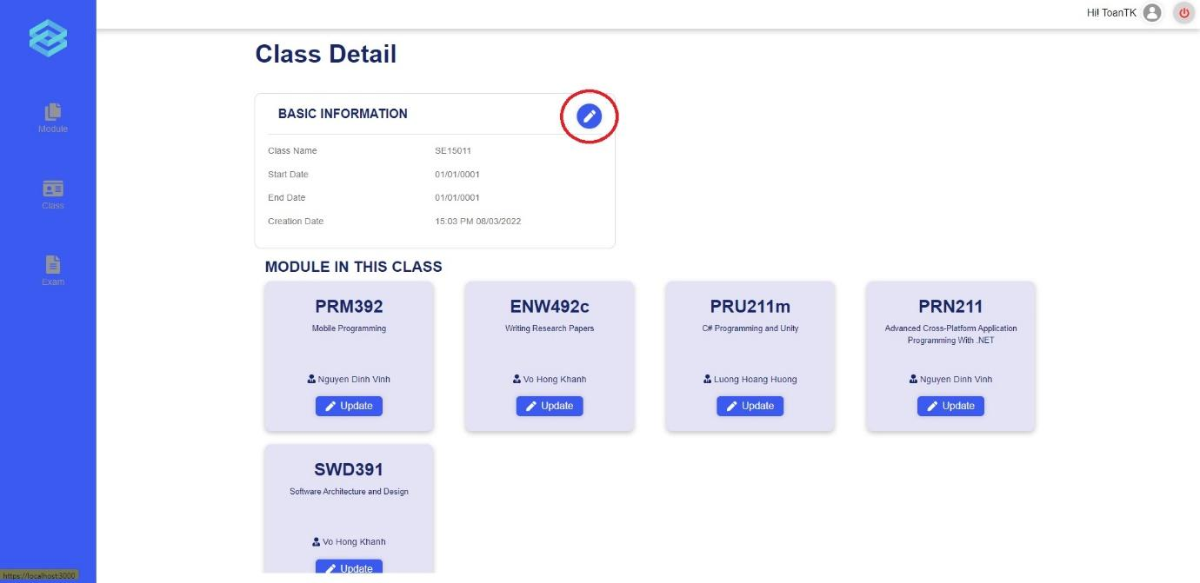
Figure 35. Class Detail

c. Manage exams
- Triggering a function: Login successfully, click on “Exam” to go to the exam list page (Figure 36), click on “Detail” on an exam to view the details of that exam (Figure 37), here, you can cancel or update the information of the exam. Returning to the exam list page, click on the “+” icon to start creating exams (Figure 38), here, you can create an exam.
- Description of the function: an Academic Department user is allowed to manage exams. including view exam list, create, update, cancel exams.
- Details of the function:
  - Normal execution case: Successfully, an Academic Department user has access to the Exam List page and on each exam, has access to viewing the details of an exam and updating or cancelling an exam, they can also create an exam.
  - Abnormal execution case: Loss of connection.
- Layout of the screen:
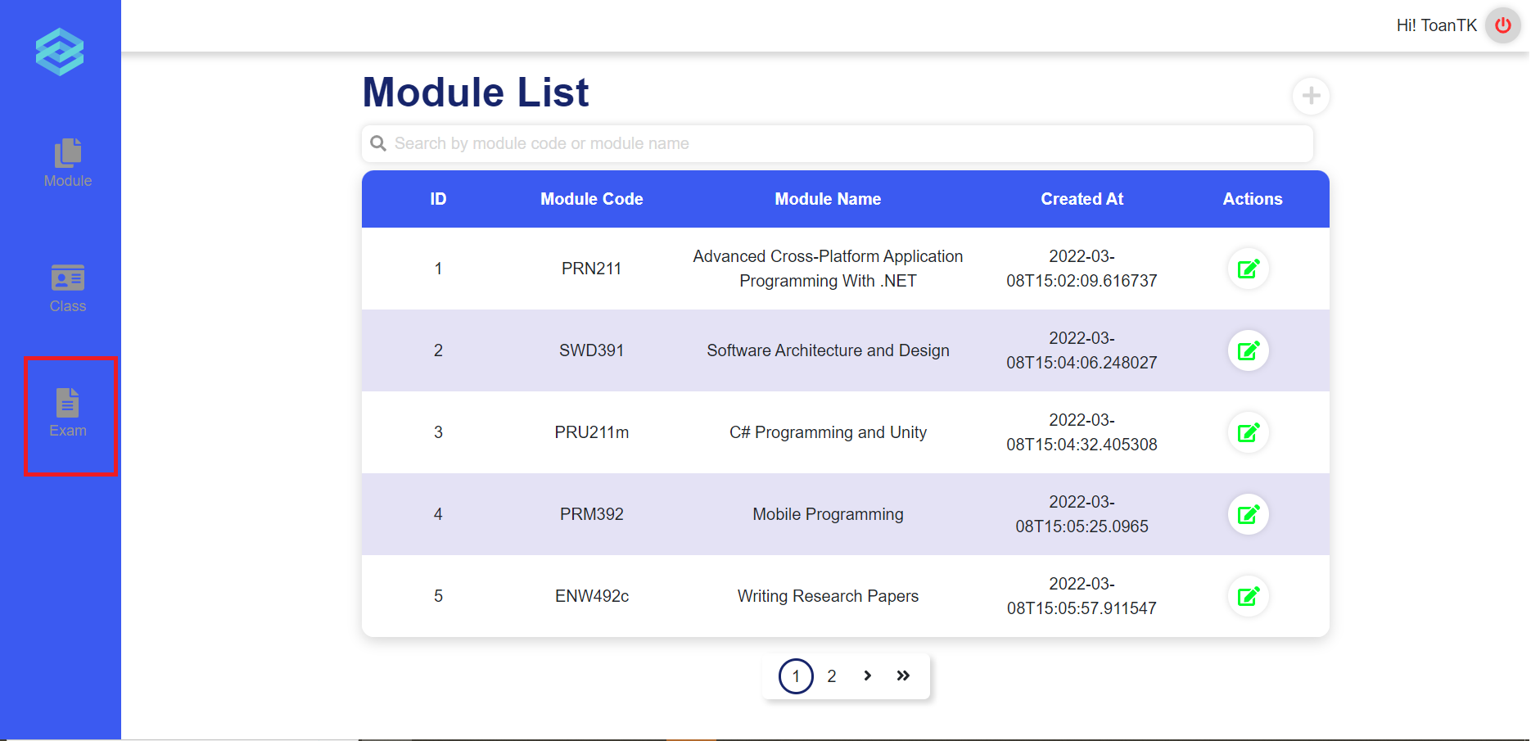
Figure 36. Module List
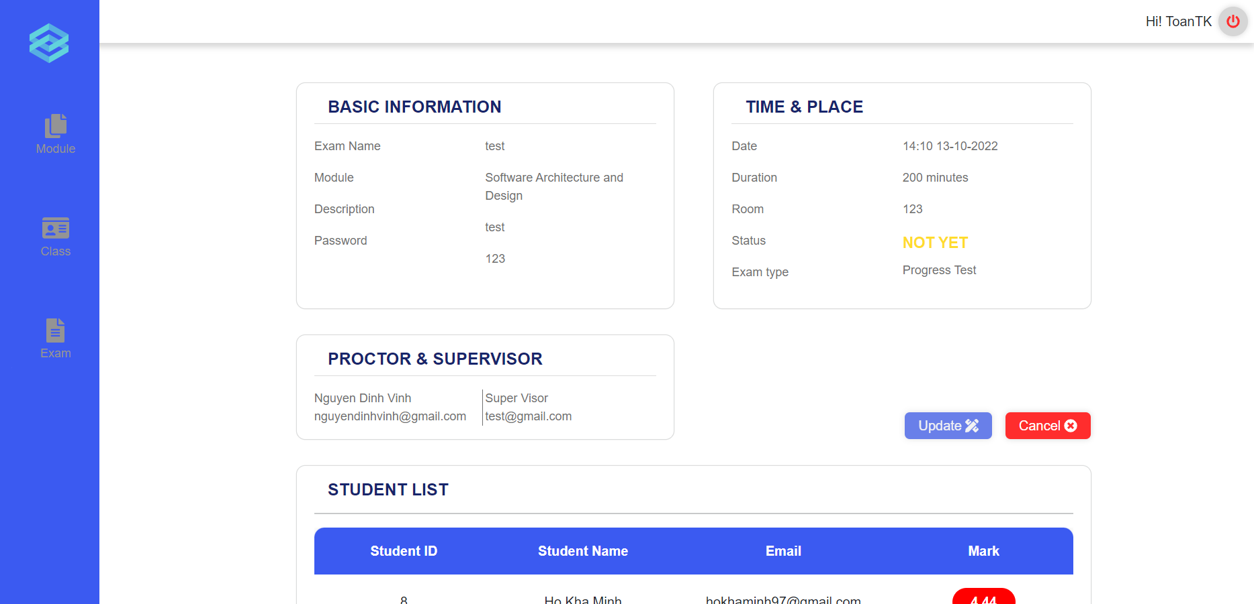
Figure 37. Exam Detail
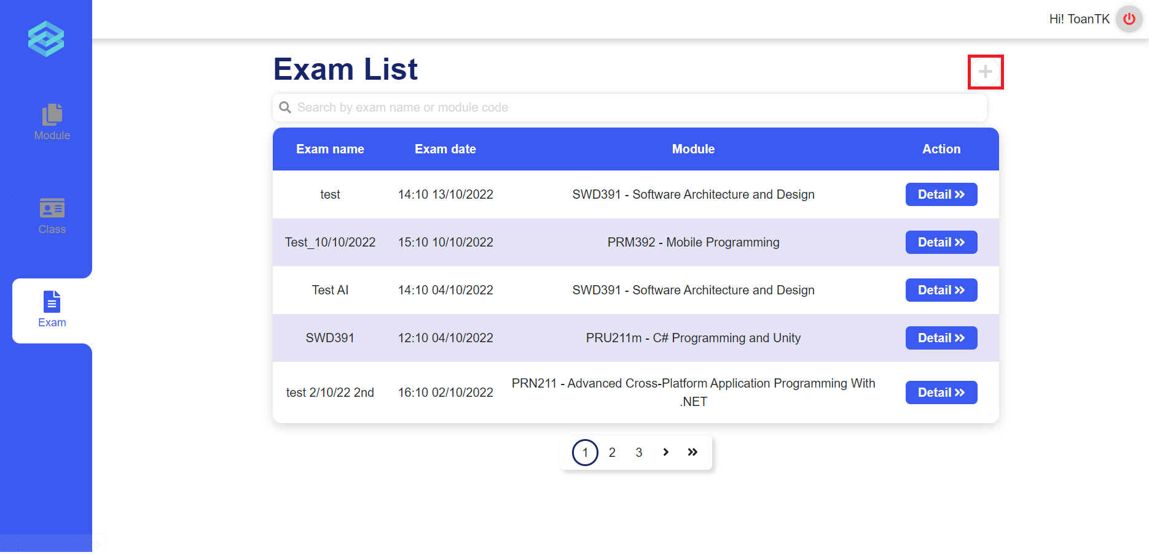
Figure 38. Exam List
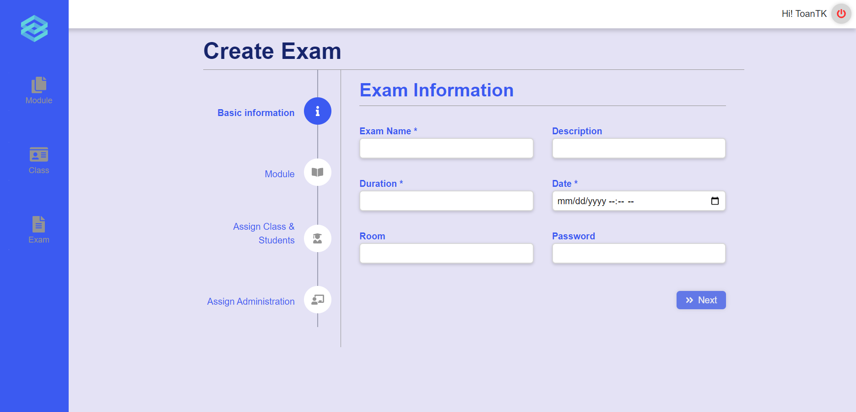
Figure 39. Create Exam

3.5 Role Teacher

a. Manage Exam
- Triggering a function: Login successfully with the teacher account. Click on the “Create Exam” icon on the vertical navigation bar to go to the create exam page (Figure 40). Click on the “Module” icon on the vertical navigation bar to go to the module list page, click on the module tab to expand it and click on the appropriate class under each module tab to go to the exam list (Figure 41). Click on the “Detail” button in the exam card to view detail, update and cancel that exam (Figure 42,43).
- Description of the function: Allow a teacher user to view the exam list, view detail of the exam, and create, update and cancel the exam.
- Details of the function:
  - Normal execution case: A teacher user can successfully access the create exam page and create a new exam. Also can successfully access the exam list page and on each exam, has access to viewing the details of the exam and updating or cancelling the exam.
  - Abnormal execution case: Loss of connection.
- Layout of the screen:
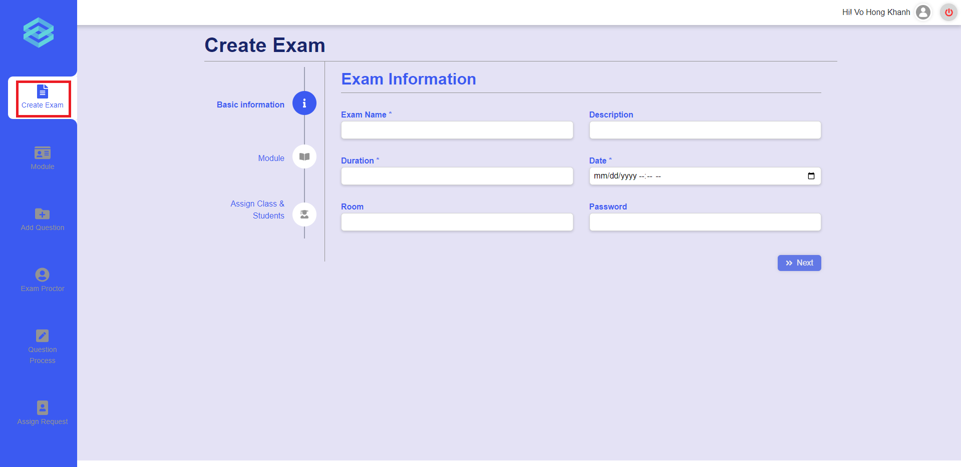
Figure 40. The create exam page
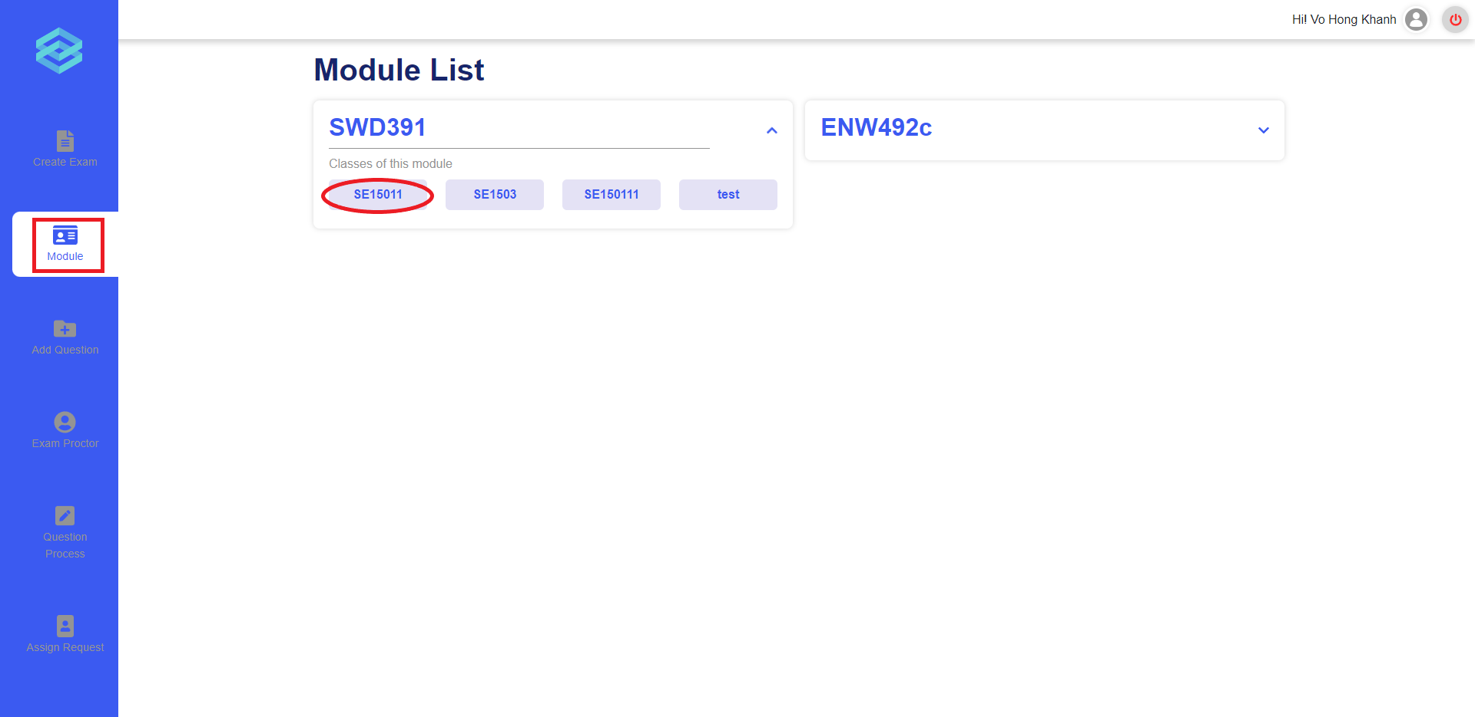
Figure 41. The module list page
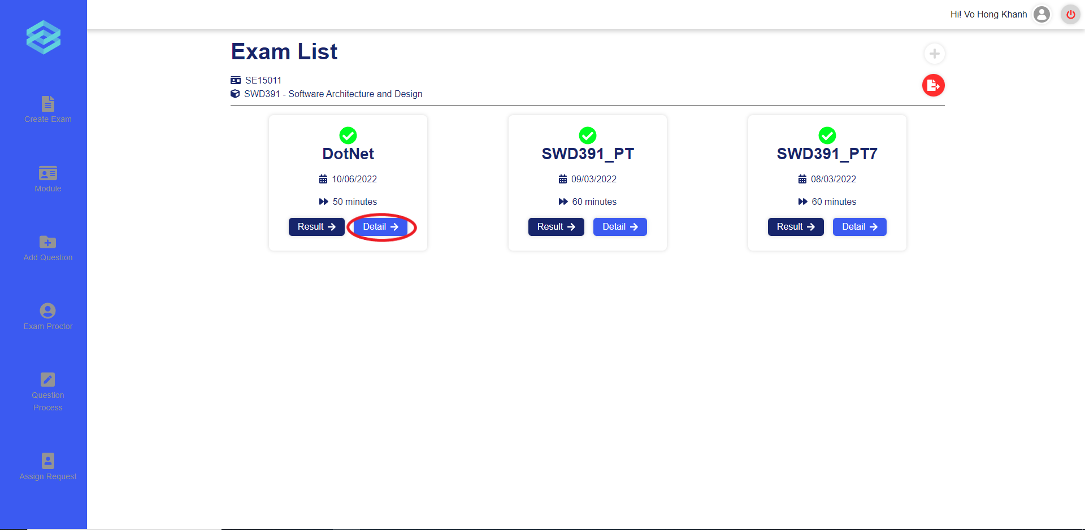
Figure 42. The exam list page
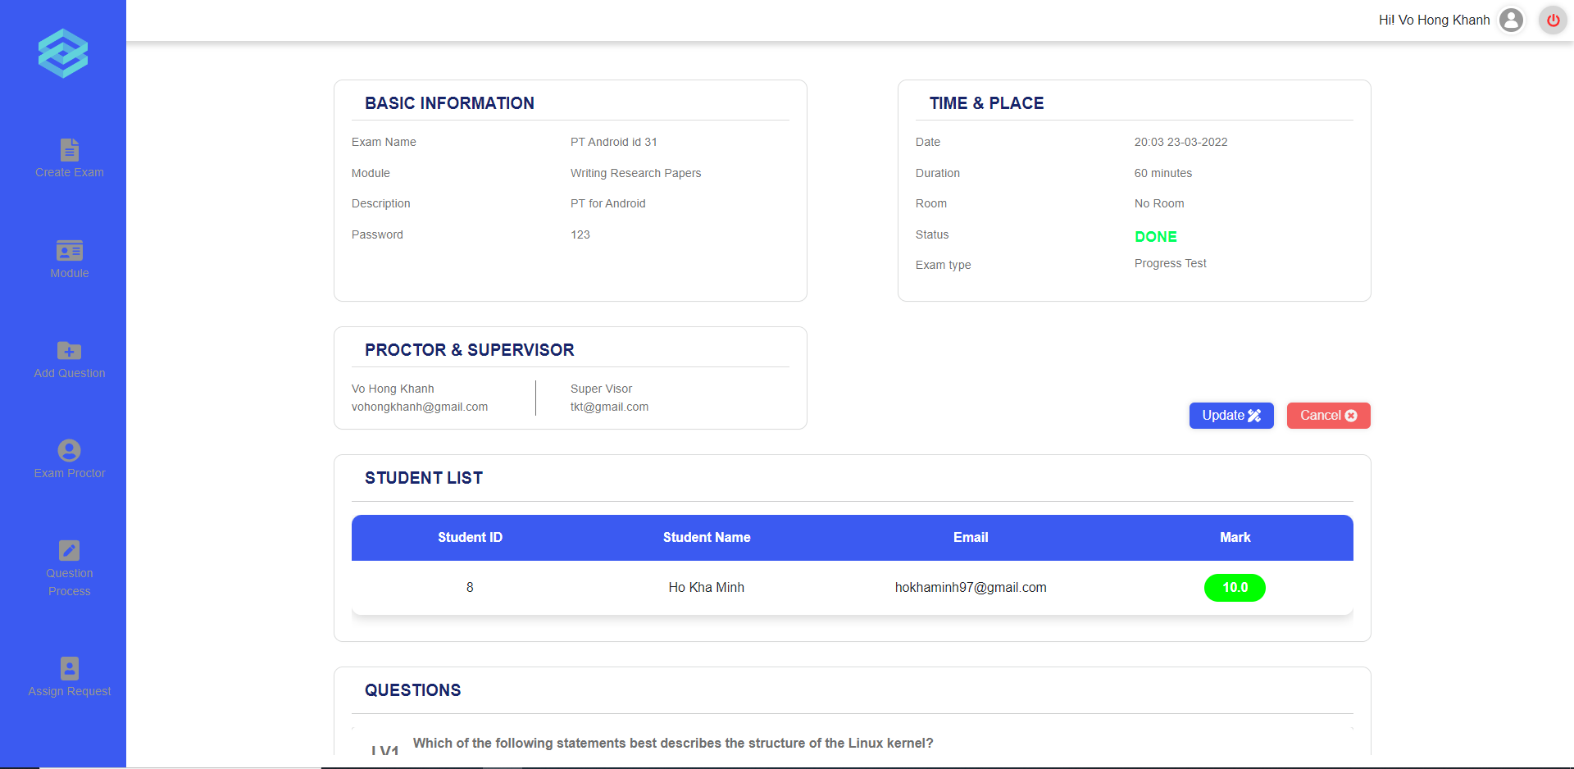
Figure 43. The exam details page

b. Grade written question
- Triggering a function: Login successfully, click on section “Module” (Figure 44), click on the right class associated with the module, then click on “Result” (Figure 46) on the right exam. In the result page, click on the “Grade” icon of each student mark row (Figure 47) to view their answers and give marks (Figure 48).
- Description of the function: a Teacher user is allowed to grade written answers of students in the exam.
- Details of the function:
  - Normal execution case: Successfully, a Teacher user submits the mark successfully.
  - Abnormal execution case: Not input or input wrong, display error message (Figure 49, 50).
- Layout of the screen:
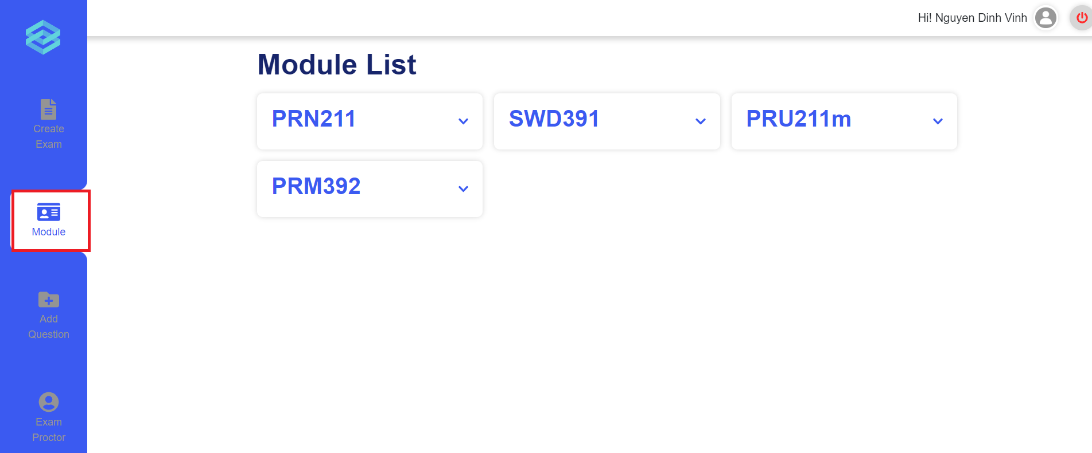
Figure 44. The module list page
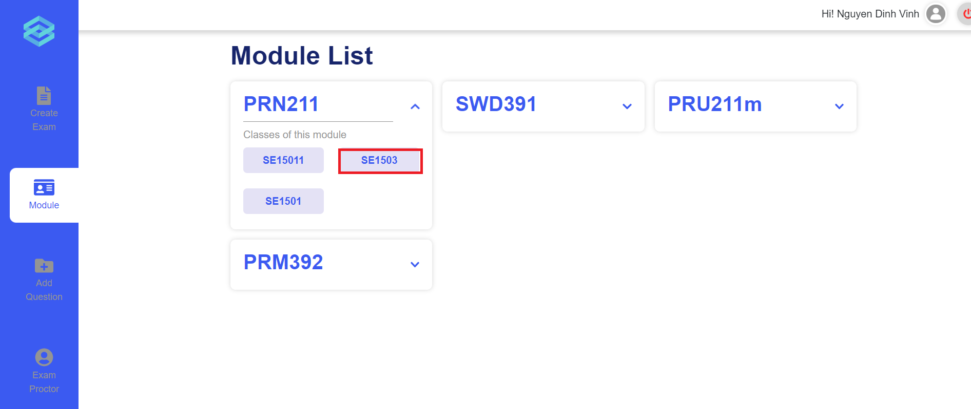
Figure 45. The class in module
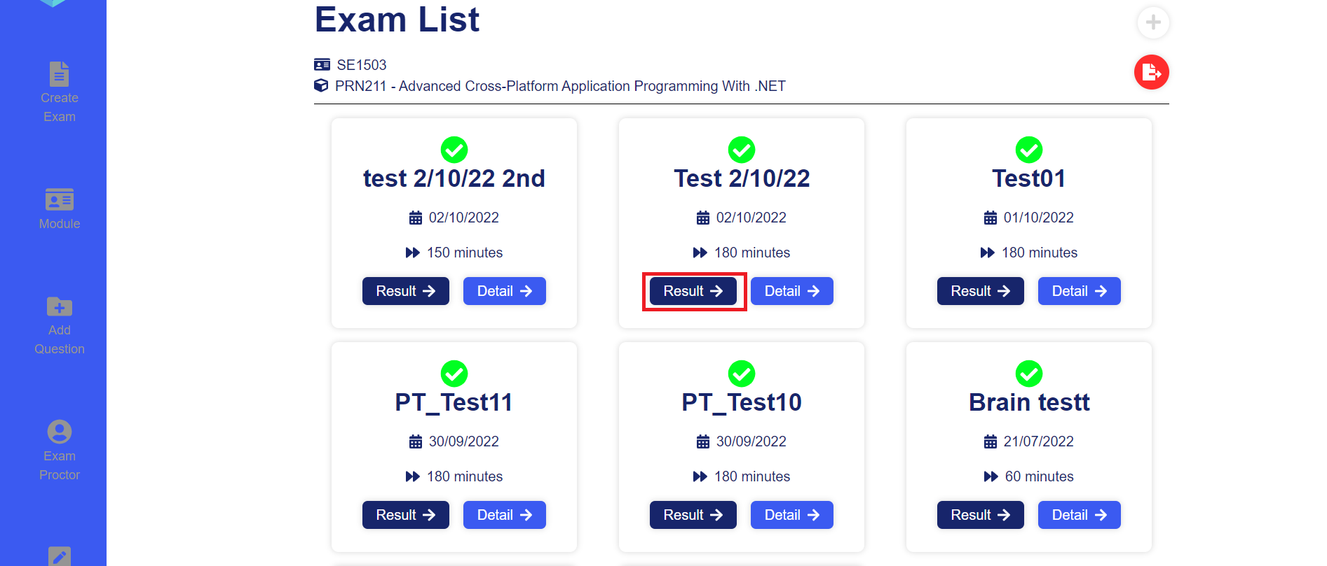
Figure 46. The Exam list page
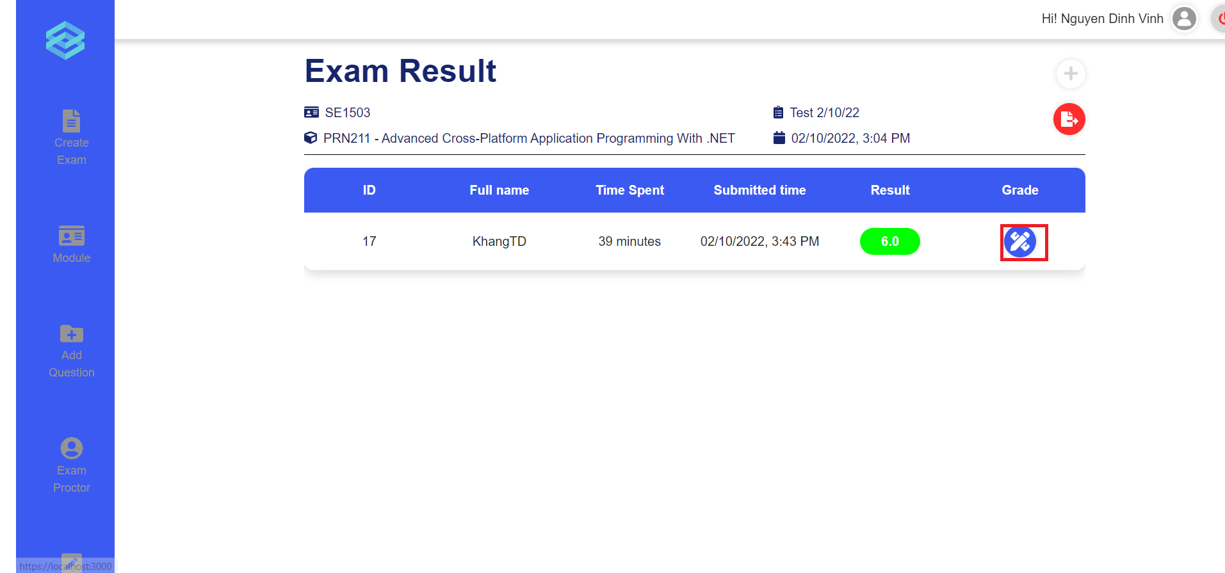
Figure 47. The exam result page
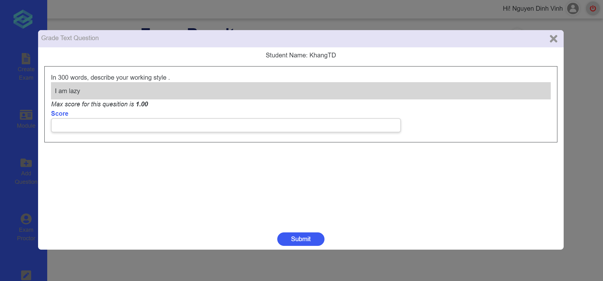
Figure 48. The Mark input modal
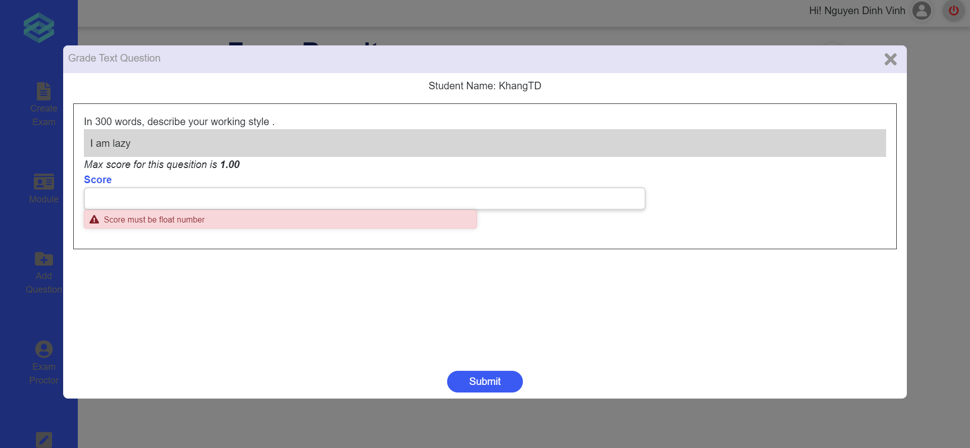
Figure 49. The mark input modal with error
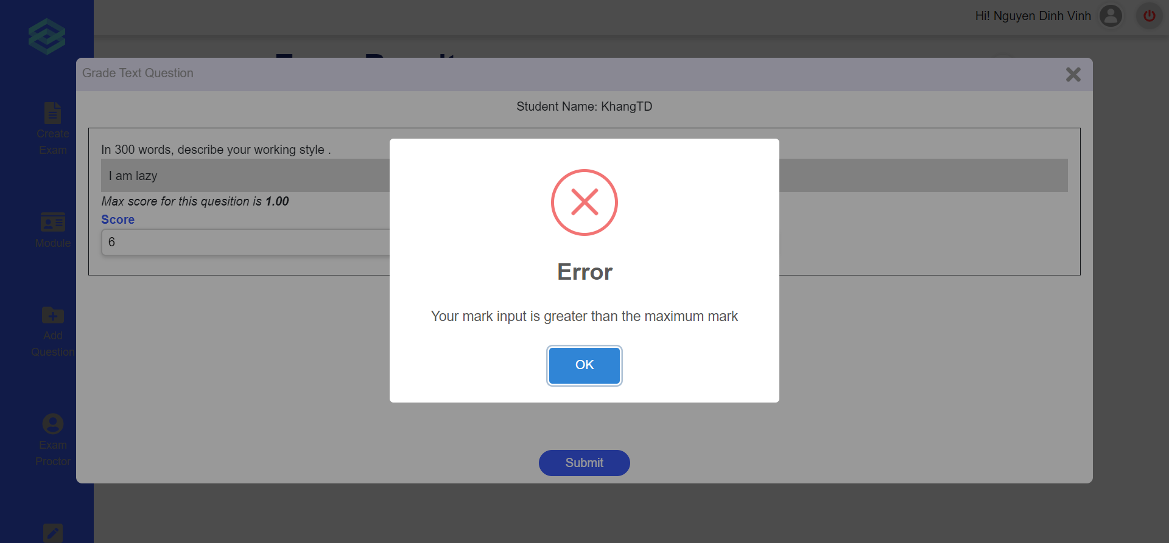
Figure 50. The error message
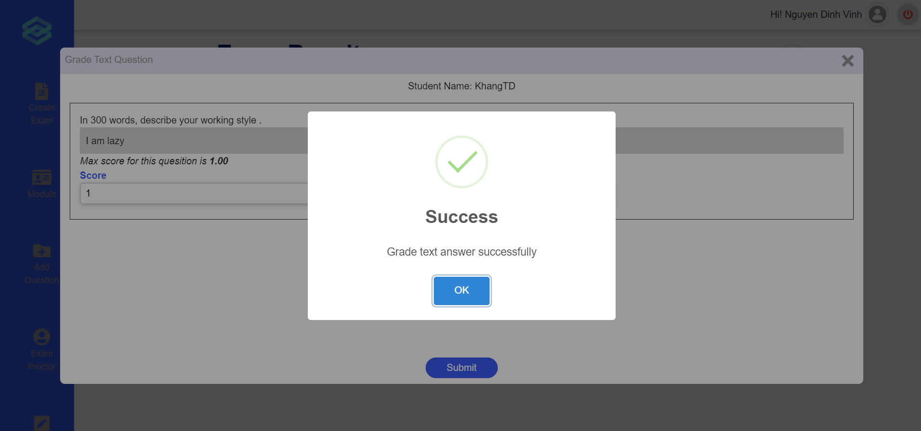
Figure 51. The success message

c. Approve/reject to add questions
- Triggering a function:
- Login successfully.
- Scroll down.
- Click on “Question Process” (Figure 53).
- Click on the arrow icon for a selected request (Figure 54).
- Tick the box on the lower right corner of each question to approve of it, leave unticked if it does not approve (Figure 55).
- Click submit to send the processed questions through.
- Description of the function: a Teacher user is allowed to approve or reject questions waiting to be added to the question bank.
- Details of the function:
  - Normal execution case: Successfully, a Teacher submits the question through.
  - Abnormal execution case: Loss of connection.
- Layout of the screen:
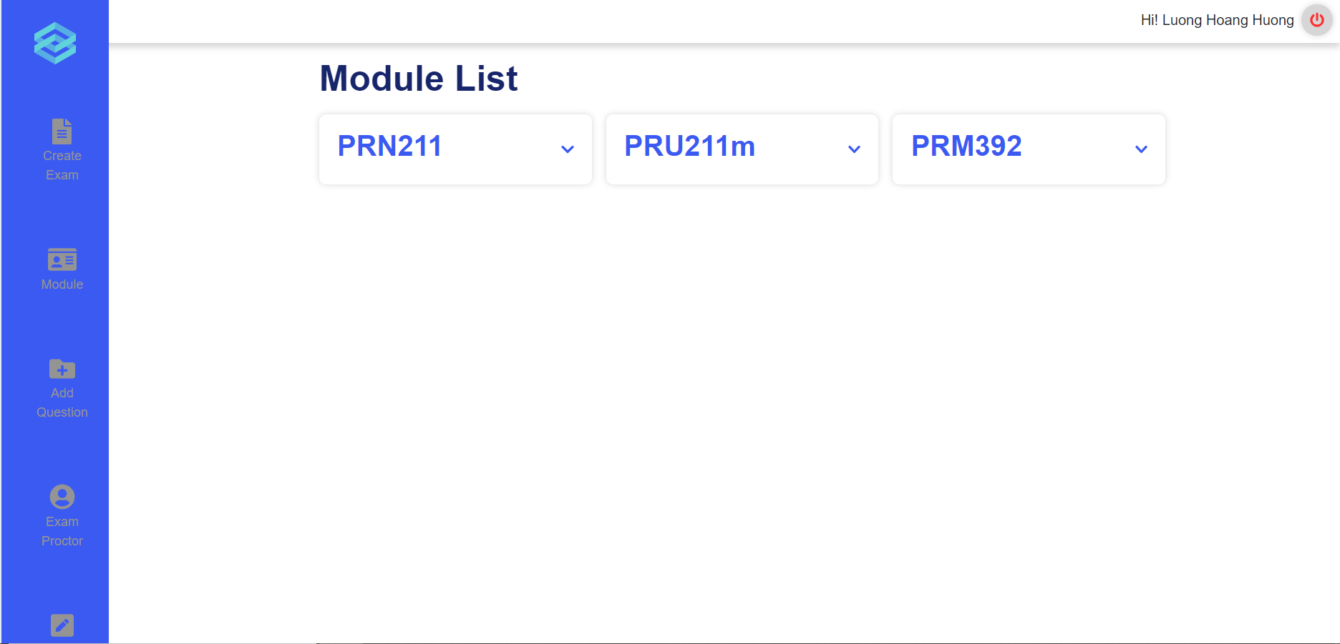
Figure 52. Module list
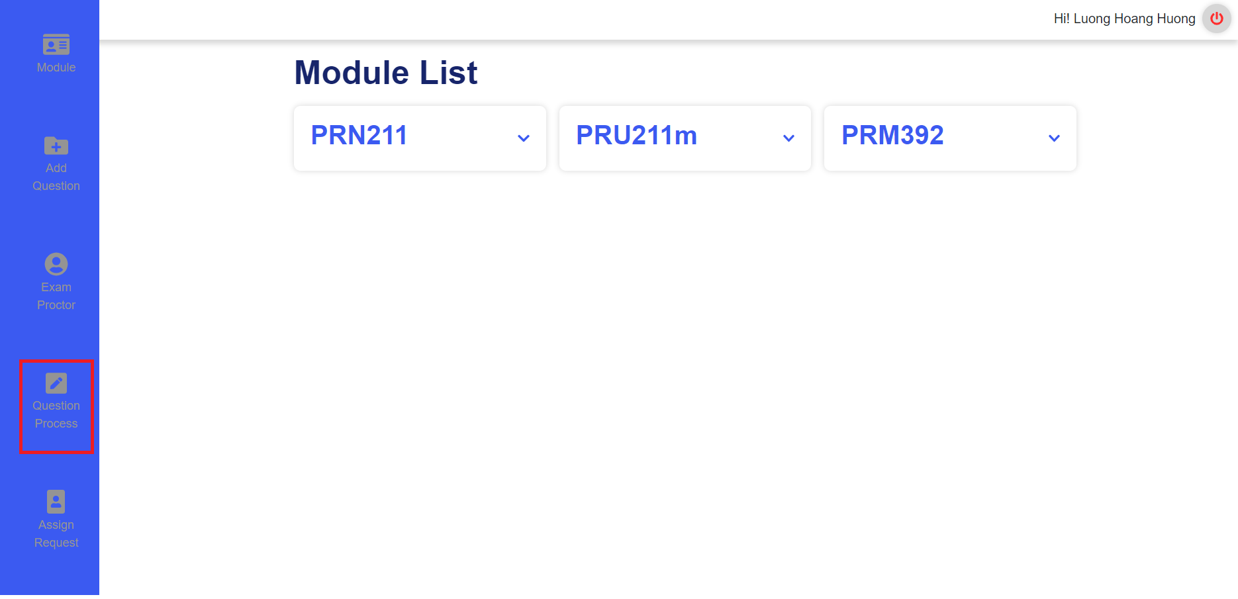
Figure 53. Scrolled down Module list
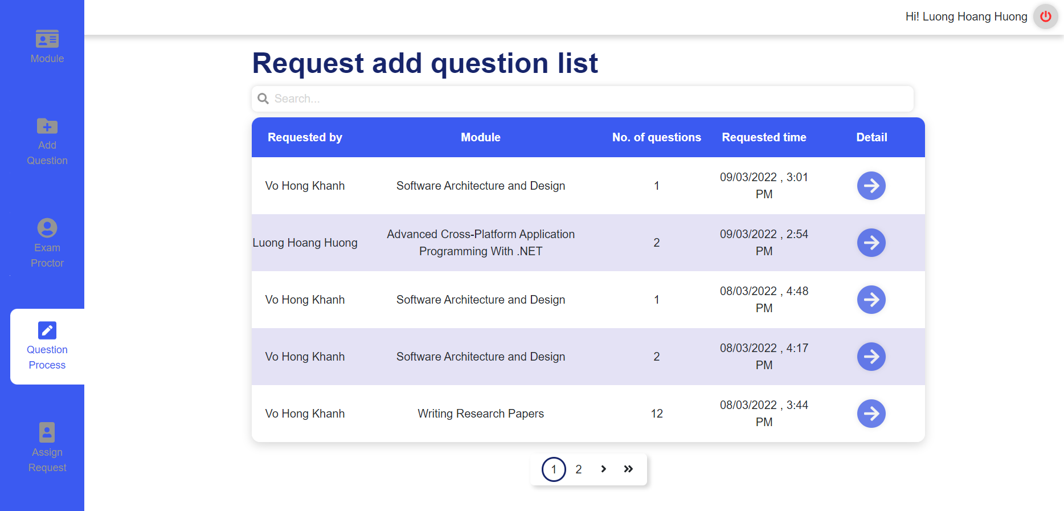
Figure 54. Request add question list
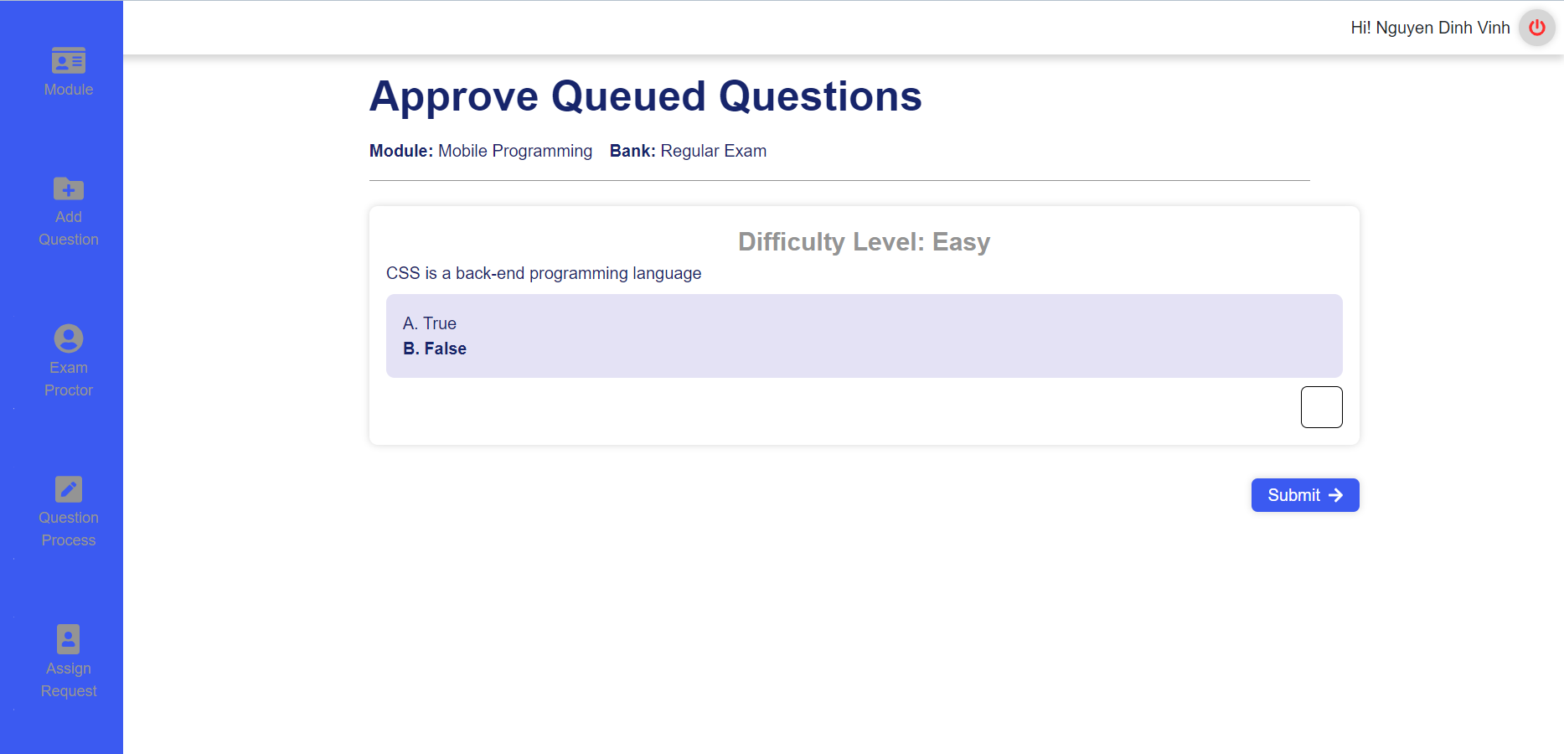
Figure 55. Approve Queued Questions

d. Request add new question to question bank
- Triggering a function:
- Login successfully.
- Click on section “Add Question” (Figure 56).
- Click on select options to choose module, bank,question type (Figure 57).
- Click on “Add new question” button to add questions (Figure 57).
- Click on “Level” select options to choose difficulty level (Figure 58).
- Input questions and answers for multiple choice questions or text questions (Figure 59, 60).
- Click on “Add new answer” in case multiple choice questions (Figure 61).
- Click on the radio button to choose the right answer in case multiple choice questions; (Figure 61).
- Click “Choose file” to add images if necessary (Figure 62).
- Click the “Trash” icon to delete questions (both question types) or answers (in case multiple choice questions) if necessary (Figure 63).
- Click “Send request” to confirm and submit (Figure 64).
- Description of the function: a Teacher user is allowed to create new question request to add to the question bank
- Details of the function:
  - Normal execution case: Successfully, a Teacher user creates new question requests and send these questions to the question bank (Figure 65, 66)
- Layout of the screen:
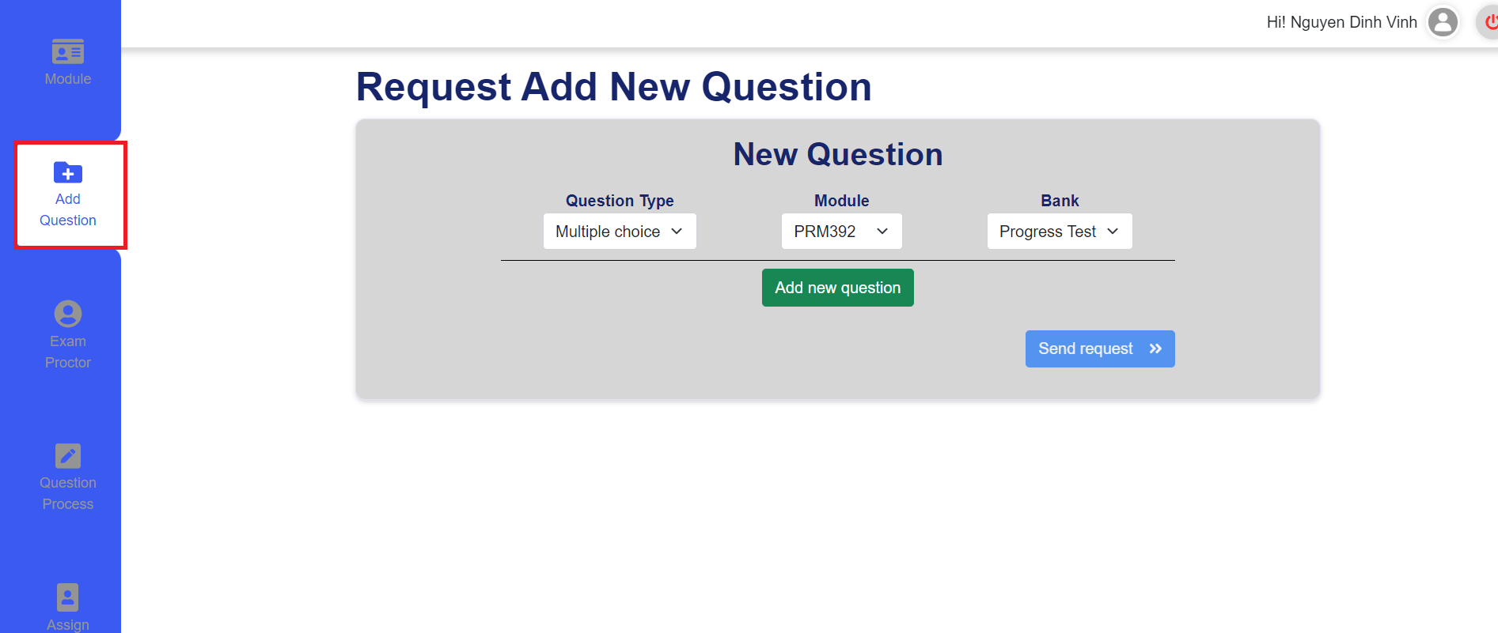
Figure 56. The add request question
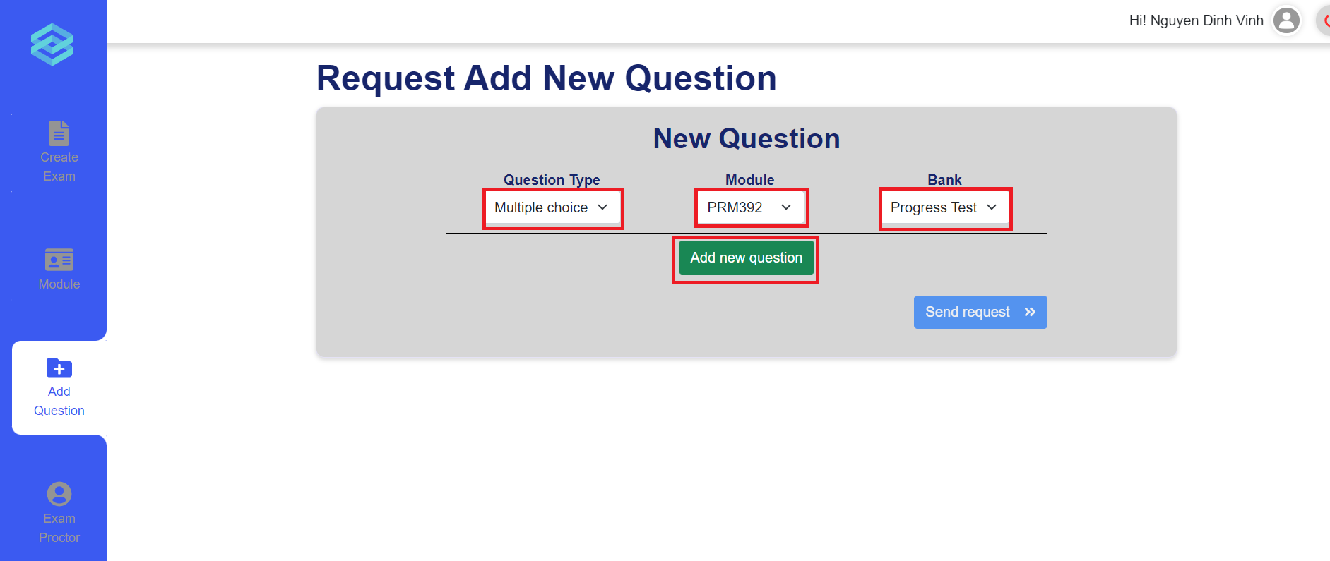
Figure 57. The add request question detail
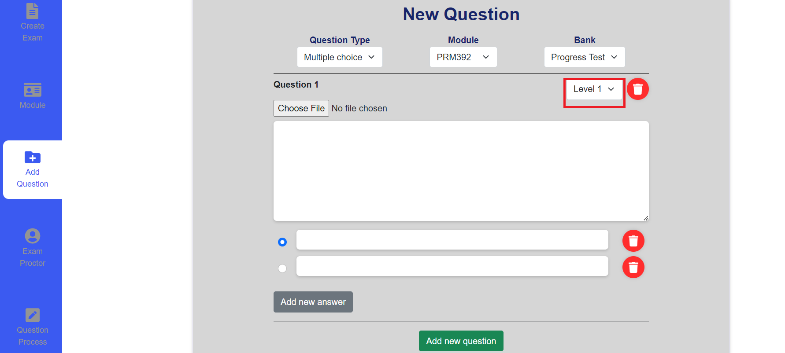
Figure 58. New multiple choices question blank for input
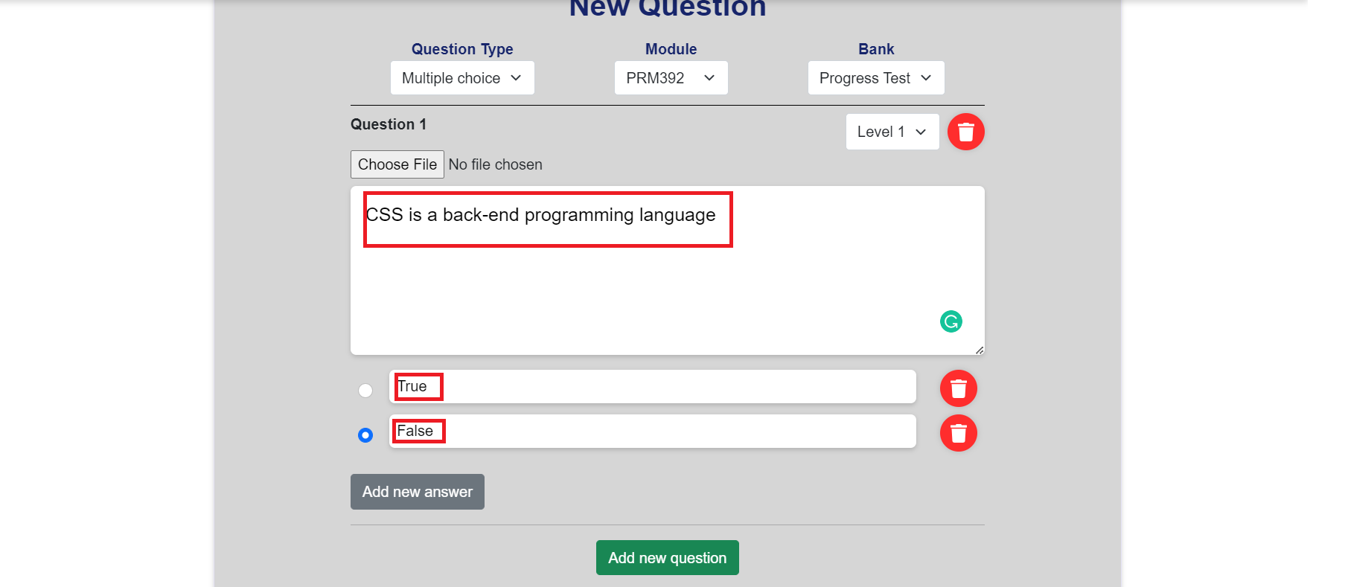
Figure 59. Input multiple choice question
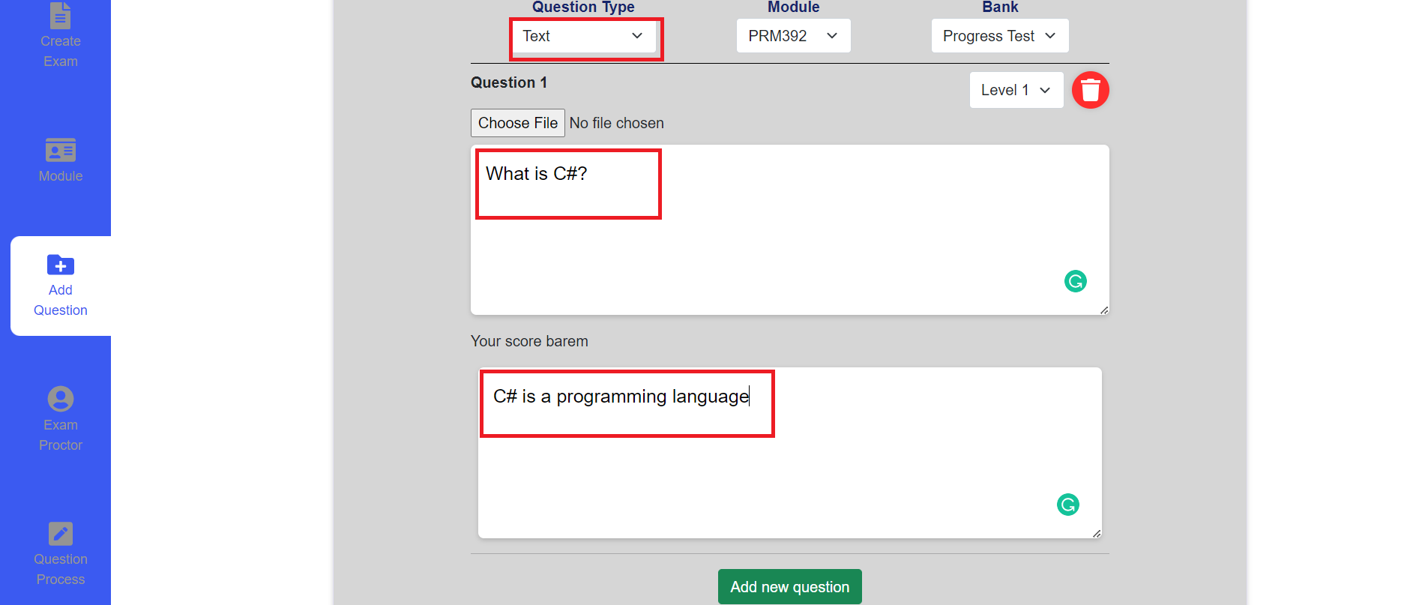
Figure 60. Input writing question
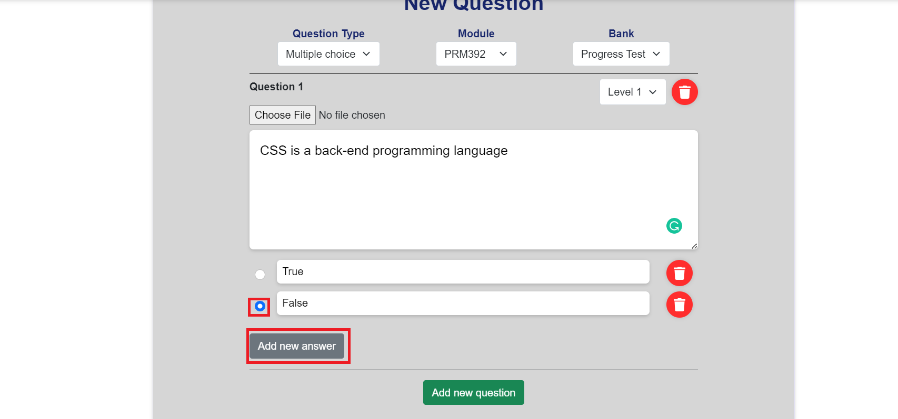
Figure 61. Add new answer
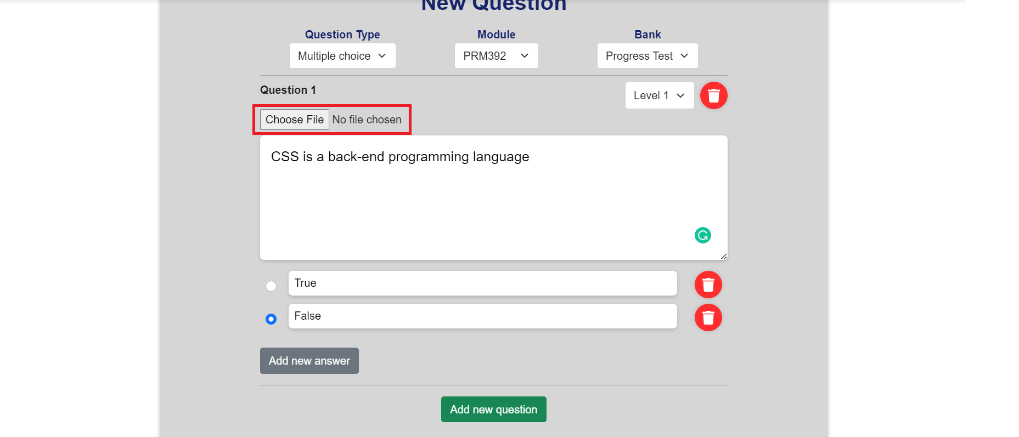
Figure 62. The Choose image button
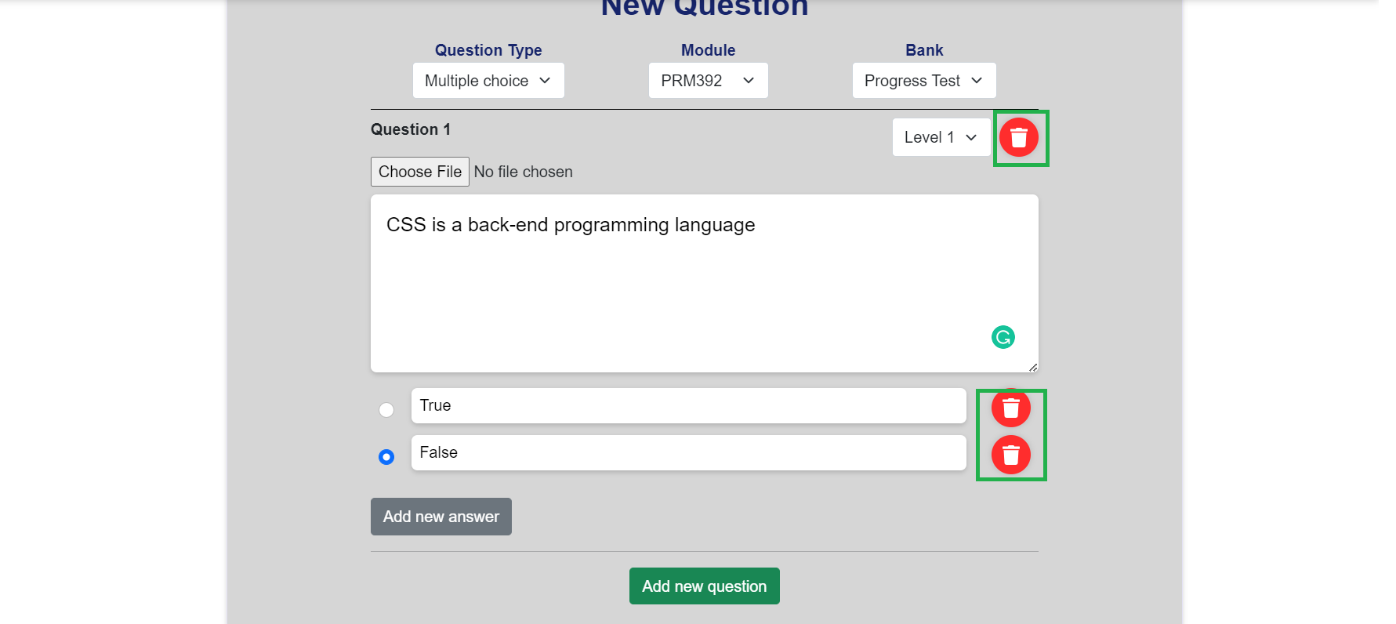
Figure 63. Delete question and answer buttons
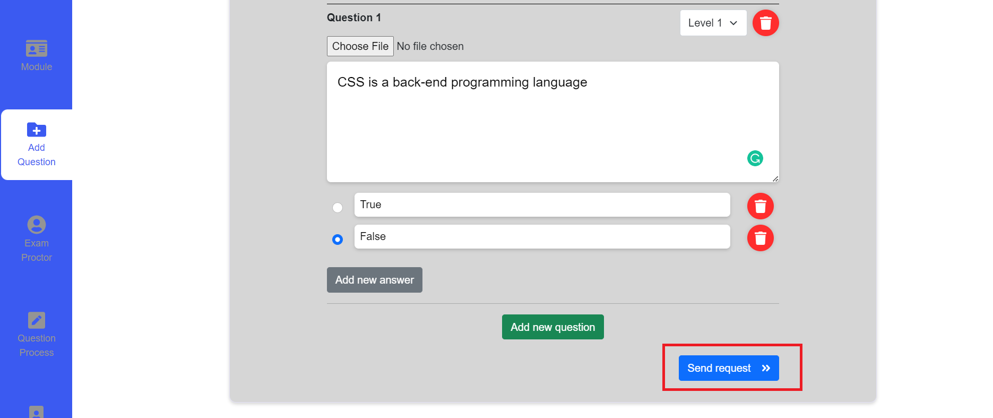
Figure 64. Send request button
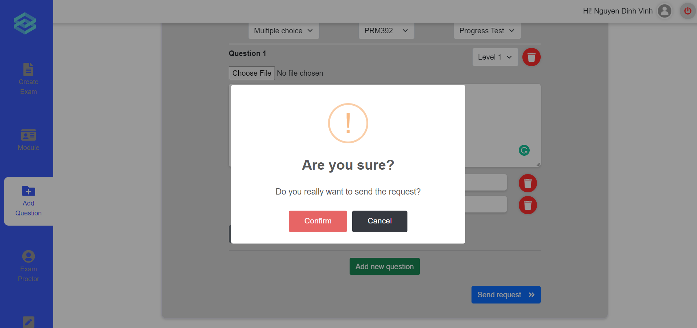
Figure 65. Confirmation message
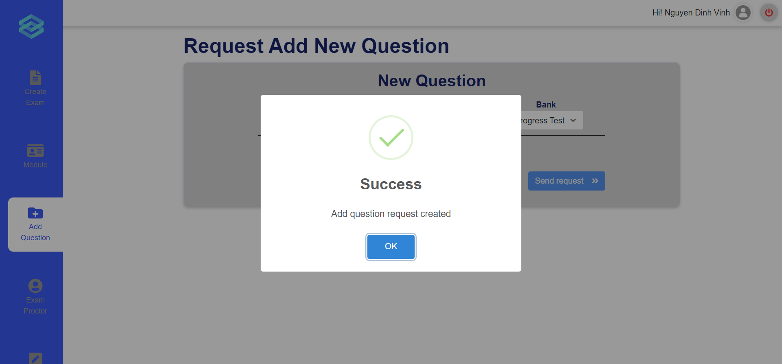
Figure 66. The success message

e. Invigilate
- Triggering a function: Login successfully with the teacher account. Click on the “Proctor list” icon on the vertical navigation bar to go to the Proctor Page (Figure 67). Click on the “Start” button on an active exam entry (Figure 68). After clicking on the start button, the proctor will be redirected to the invigilate room (Figure 69).
- Description of the function: Allow a teacher user to oversee the process of an exam by viewing the camera feed of each student.
- Details of the function:
  - Normal execution case: The teacher is able to access the invigilate page and is able to view the camera feed of all students currently taking the exam.
  - Abnormal execution case: Loss of connection.
- Layout of the screen:
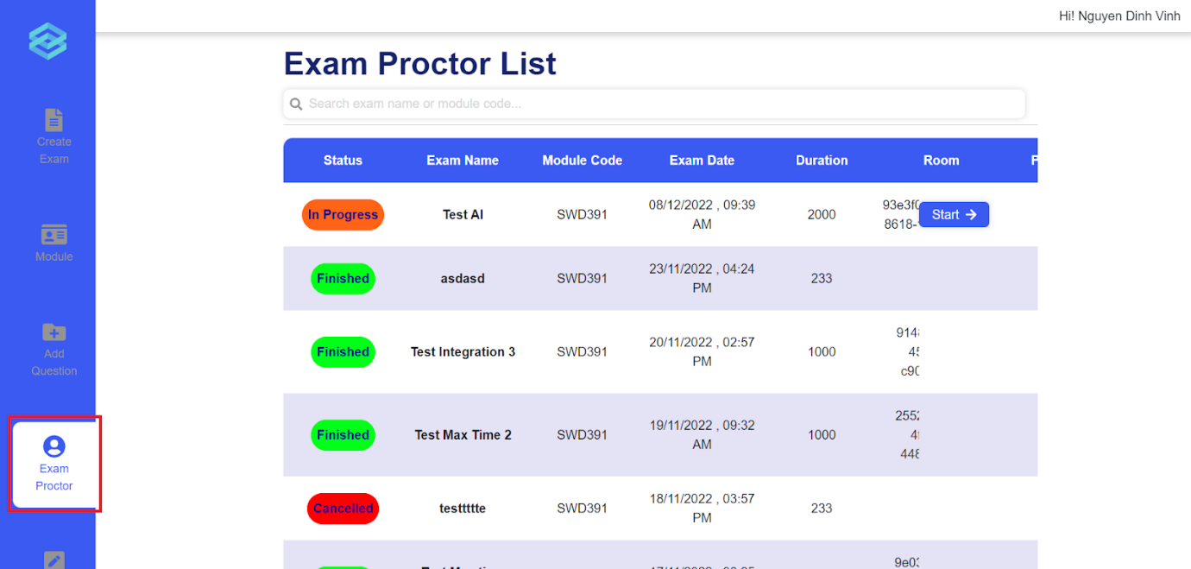
Figure 67. Exam Proctor List

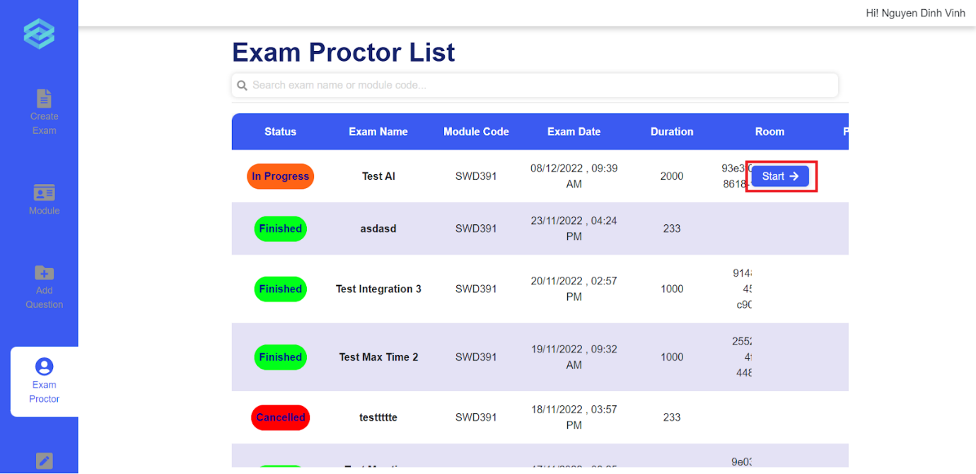
Figure 68. Clicking the Start button

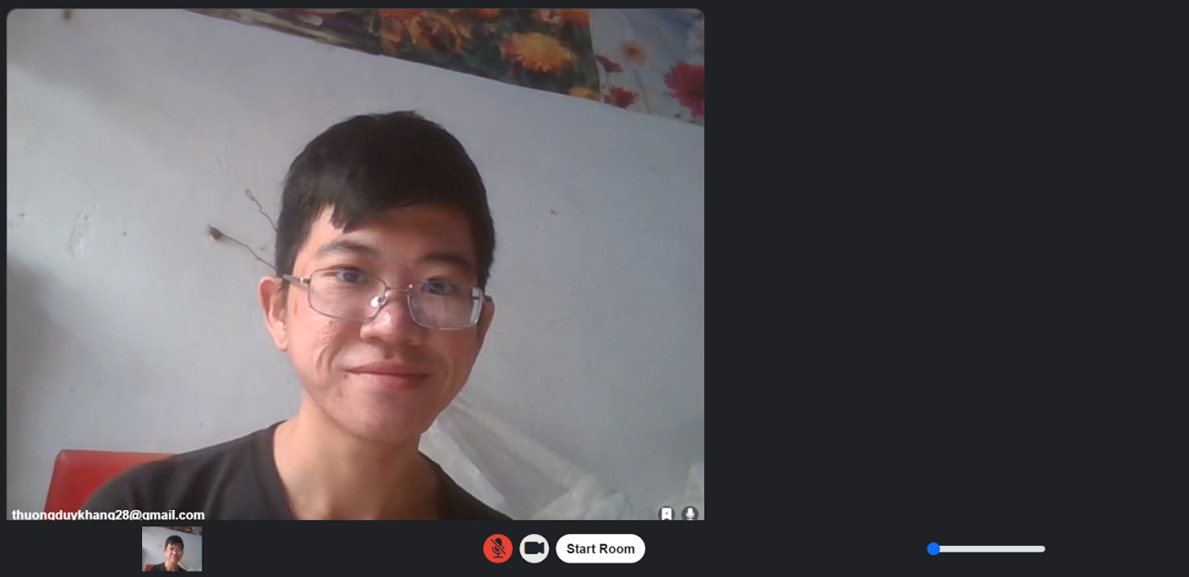
Figure 69. The Invigilate room

3.6 Role Student

a. Take and submit Exam
- Triggering a function: Login successfully; On the Exam schedule page, click on “Start” button on the exam appearing on the page (Figure 70), input password (if necessary) (Figure 71); click on “Join room” button when the online exam room is ready (Figure 72).
- Description of the function: a Student user is allowed to view, do and submit the exam.
- Details of the function:
  - Normal execution case: Successfully, a Student user accesses the Exam page and views all the exam questions (Figure 73). Moreover, after done, student answers are submitted successfully and displayed the multiple choice mark the pop up modal (Figure 74).
  - Abnormal execution case: If there are questions not answered yet, display warning modal (Figure 75).
- Layout of the screen:
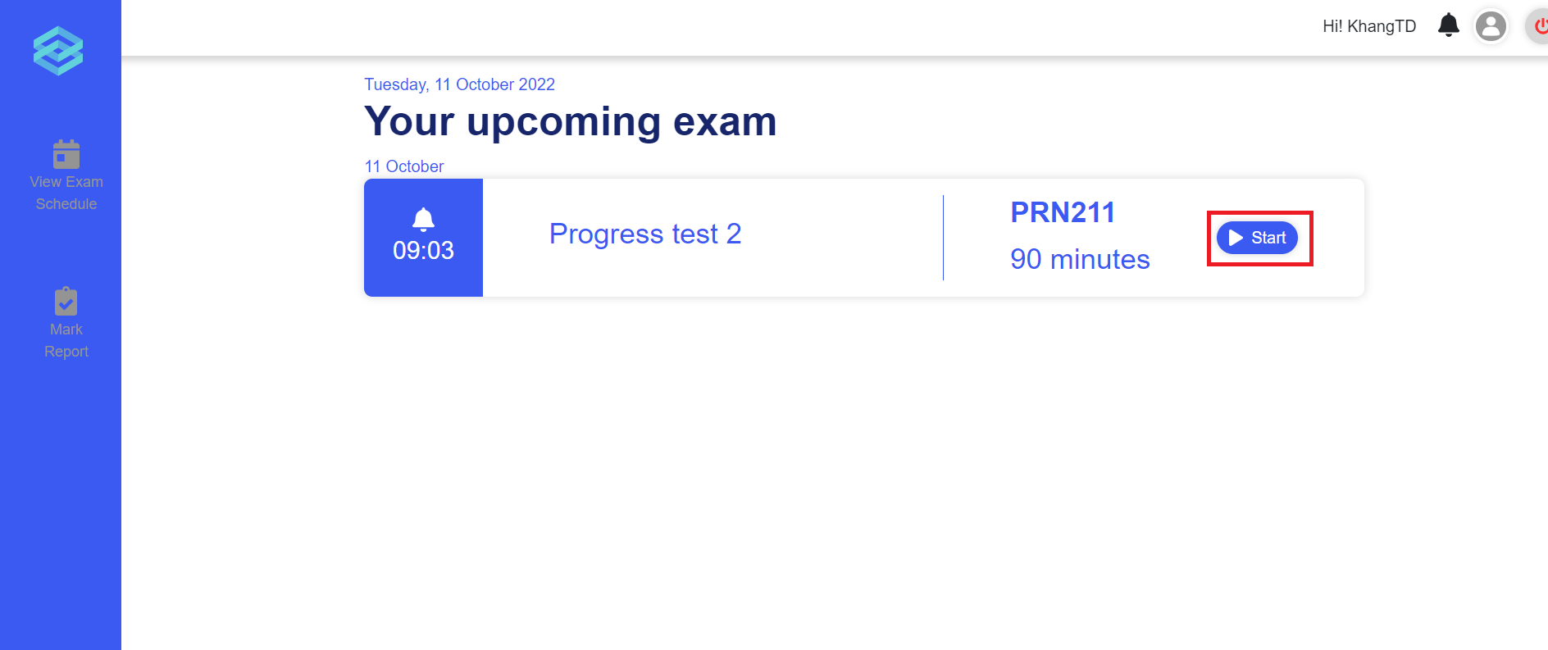
Figure 70. The exam schedule page
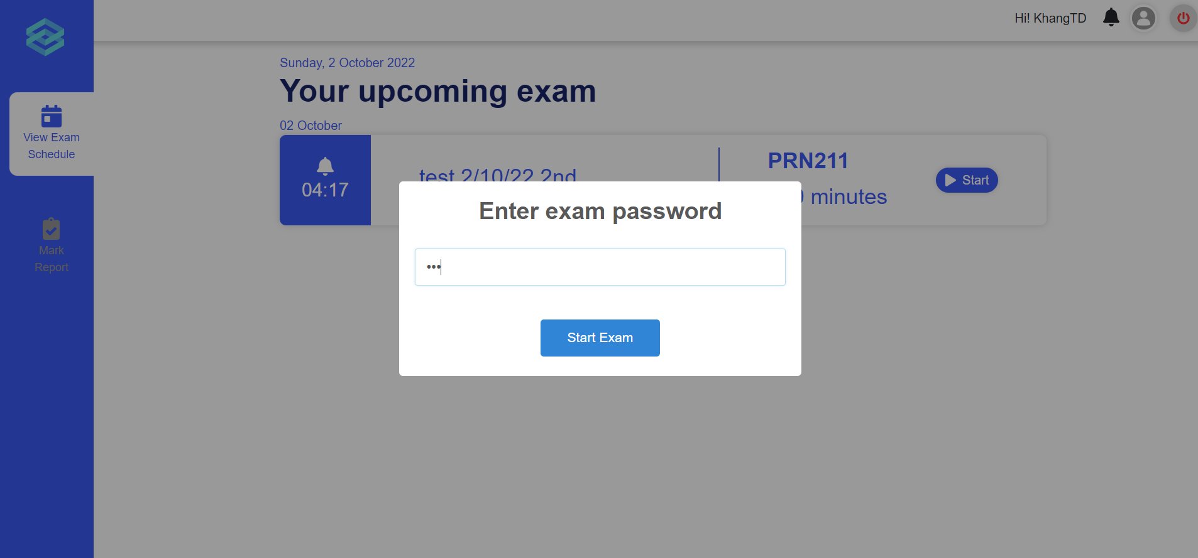
Figure 71. The password input
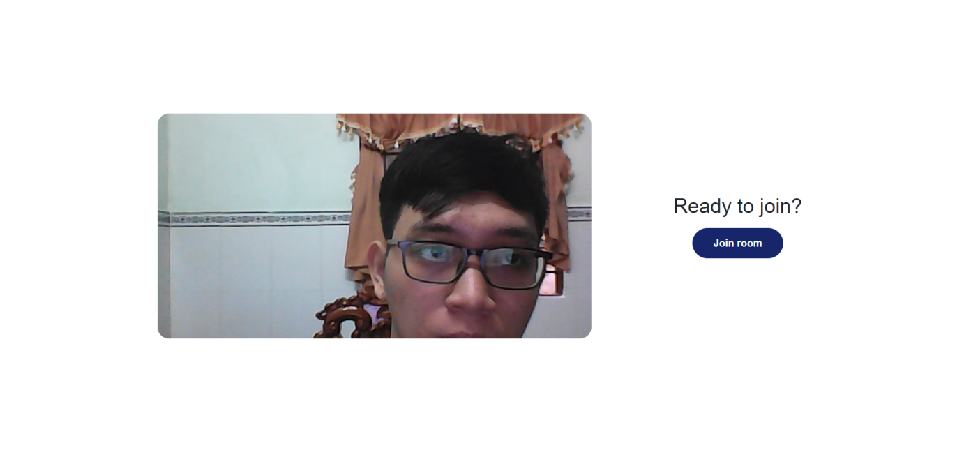
Figure 72. The student waiting room
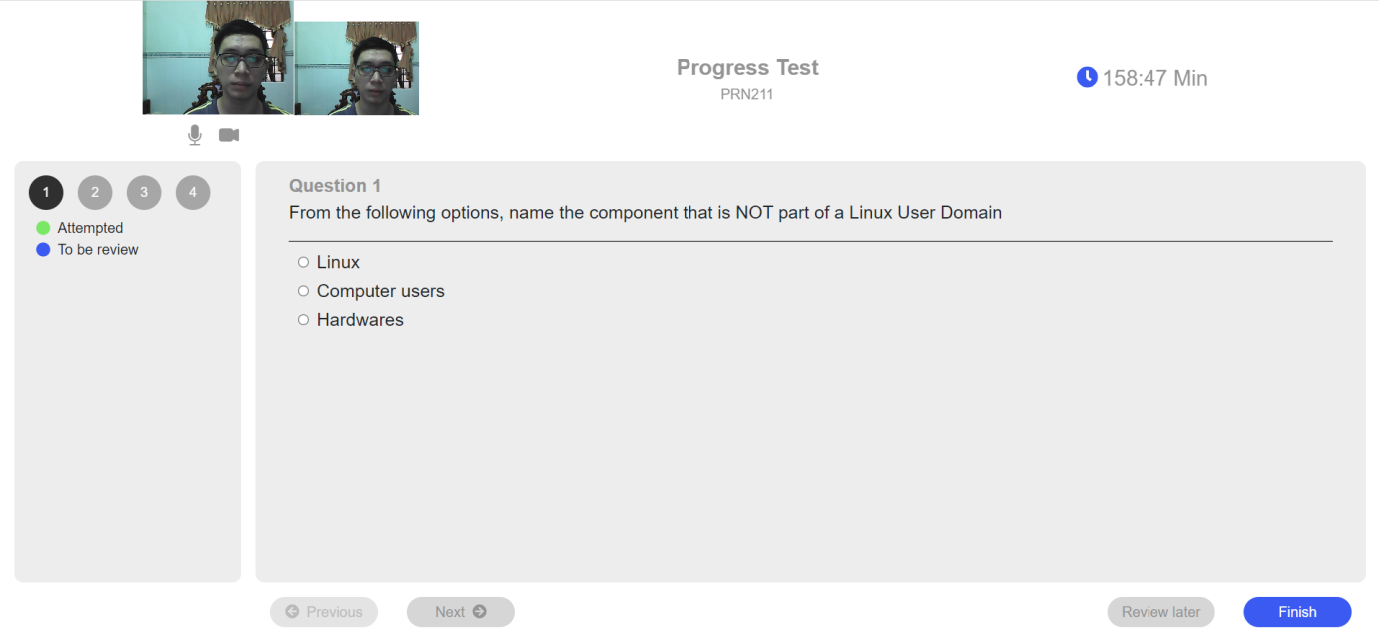
Figure 73. The exam page
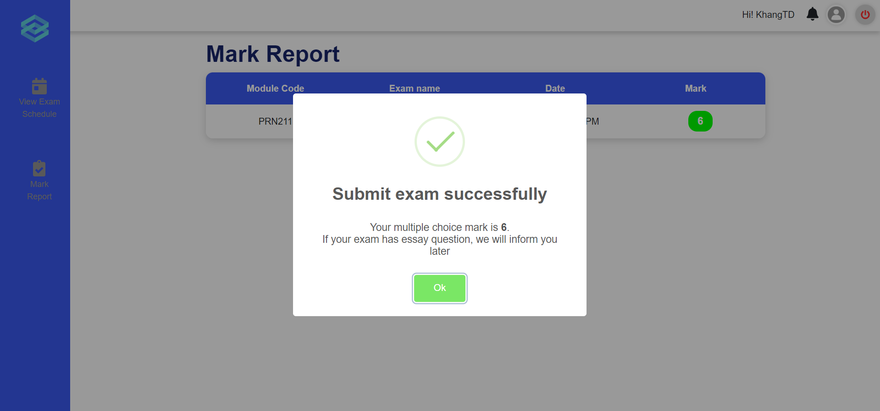
Figure 74. The mark notification pop up for multiple choice questions
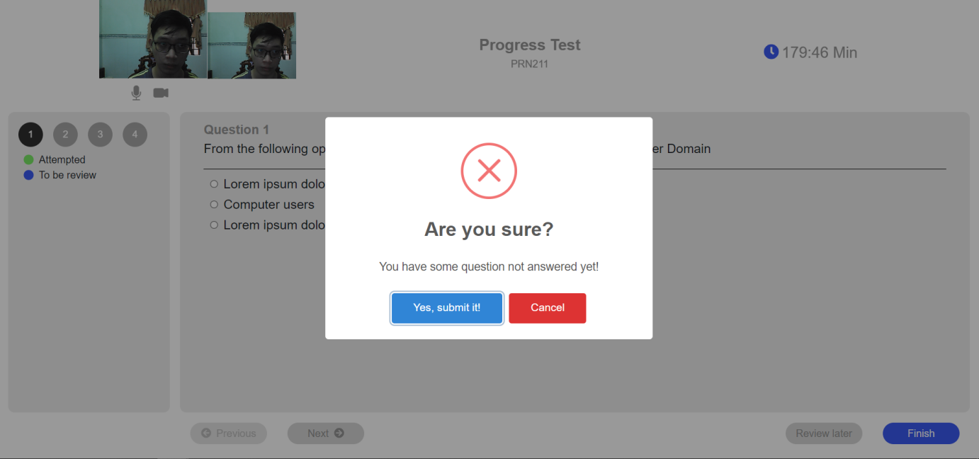
Figure 75. The warning message modal

b. Mark report
- Triggering a function: Login as a Student successfully, click on the section “Mark Report” on the left vertical navigation bar.
- Description of the function: A student user is allowed to view their taken exam list and their test result.
- Details of the function:
  - Normal execution case: Successfully, a student user has access to the taken exam list page (Figure 76) and on each module, has access to view the mark list.
- Layout of the screen:
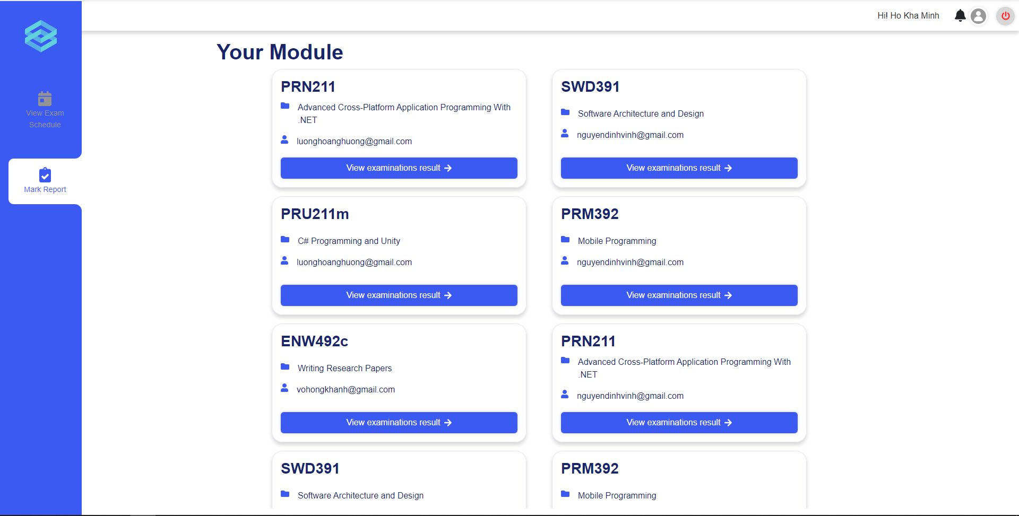
Figure 76. Taken exam list
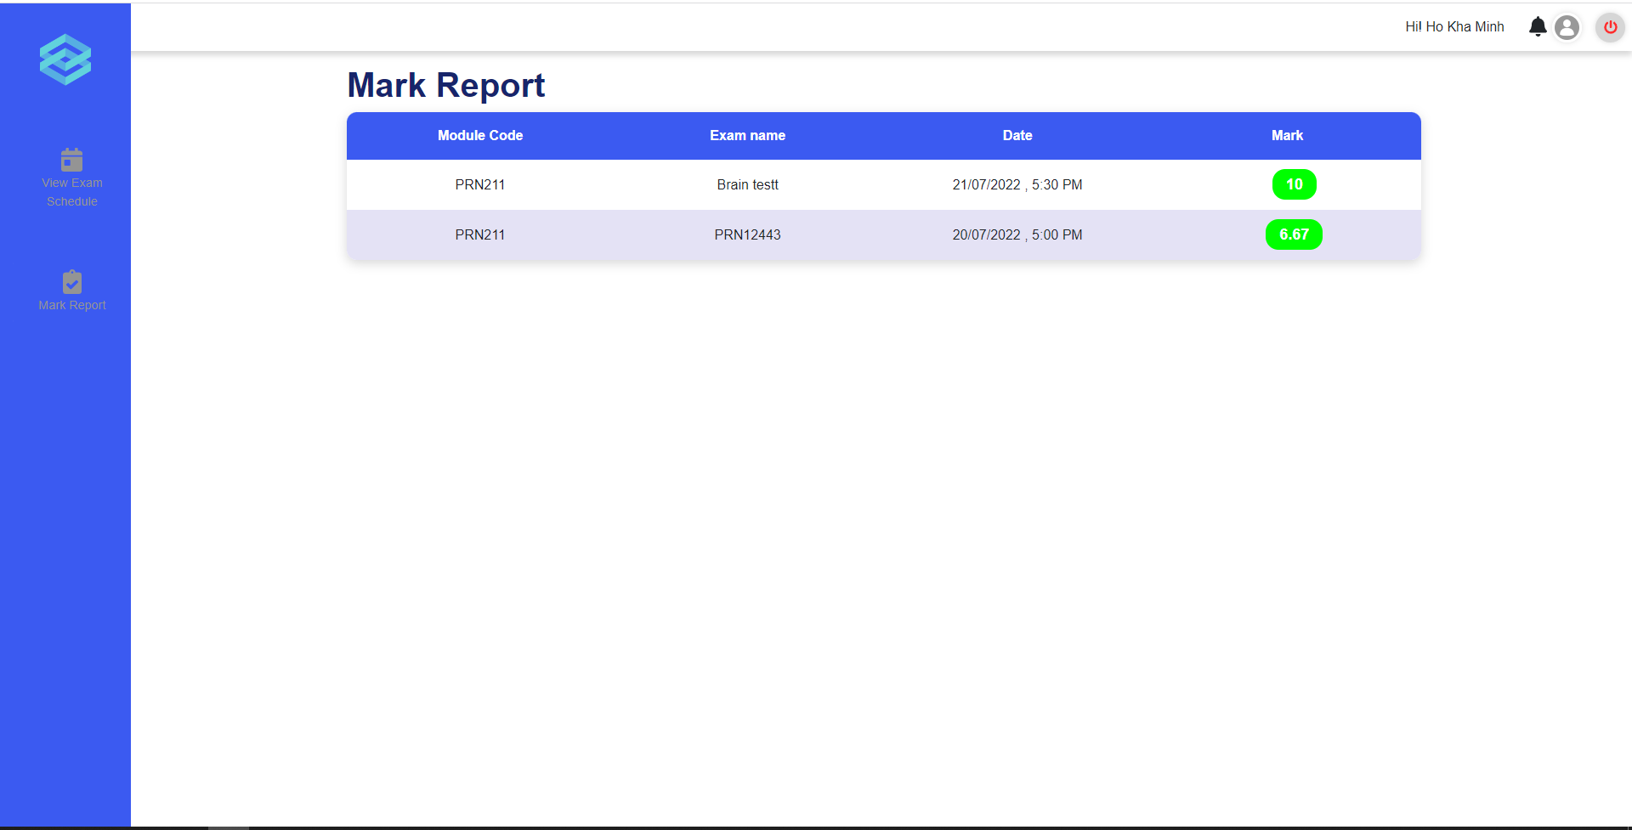
Figure 77. Mark report

4. Non-Functional Requirements

4.1 External Interfaces

a. User Interfaces
UI-1: The left vertical navigation bar always shows to navigate to another page quickly (exam taking function is exceptional).
UI-2: Users can click on the website's logo on the left vertical navigation bar to return to the website's homepage.
UI-3: Users can click the logout icon on the top horizontal navigation bar to log out (exam taking function is exceptional).

b. Software Interfaces
SI-1: The system is a web-based application.
SI-2: The system web pages must run smoothly on common web browsers (Chrome, Edge).
SI-3: Each page must load less than 5 seconds.

c. Hardware Interfaces
The system has no hardware interface.

d. Communications Interfaces
CI-1: The system will send the user's password (before encrypting) to the user's email when creating an account or when the user reset the password.
CI-2: The system will send a notification to the student when they have test results.
CI-3: The system's front-end and system's back-end is connected through HTTP Response and HTTP Request.

4.2 Quality Attributes

a. Usability
USE-1: The user interface must be easy to use by students, teachers, administrator and academic department.
USE-2: The administrator, academic department and teacher can use the system after 1 week training.

b. Reliability
RE-1: The Mean Time Between Failures (MTBF) of the ExamEdu should be less than 24
hours.
RE-2: The Mean Time To Repair (MTTP) of the ExamEdu should be less than 3 hours.
RE-3: The availability of the ExamEdu should be more than 99%.

c. Performance
PER-1: The ExamEdu should support at least 1.000 users.
PER-2: The ExamEdu should support a maximum of 300 concurrent users.
PER-3: The ExamEdu should support at least 100.000 operations.
PER-4: The maximum response time when getting data should be 5 seconds.
PER-5: The ExamEdu should return the predicting cheating results within at most 3.0 seconds.

d. Dependability

Security
DE-1: All of the passwords stored in the database must be encrypted.
DE-2: Only administrators can view, create, update and delete accounts in database.
DE-3: Only Academic Department can create class and assign students to classes.
DE-4: The final exams must be created by Academic Department.

e. Supportability
SUP-1: The system will be improved and updated if there are problems reported through surveys.

f. Design Constraints
DC-1: The ExamEdu supports the English language.
DC-2: The ExamEdu is developed by .Net, ReactJS, TensorFlow (Python).

g. Support Documents
SD-1: ExamEdu must have user manual to guide user, including students, academic departments, teachers and administrators.

5. Other Requirements

5.1 Appendix1 - Messages List
# | Message code | Message Type | Context | Content
1 | MSG01 | In line, under the text box | The input field is in the wrong format | The * field is in the wrong format
2 | MSG02 | In red, under the text box | Input-required fields are empty | The * field is required.
3 | MSG03 | Toast message | Username or password is incorrect when login | Login failed!  Wrong credentials
4 | MSG04 | Toast message | Create account successfully | Account created
5 | MSG05 | Toast message | Create account fail | The * is existed

Data flow diagram
Use Case of Student
Use case Teacher and Head of Department
Use Case of Academic Department
Use Case of Administrators
Sceen Flow
ERD Diagram

